 | 
COUNCIL ASSESSMENT REPORT – MODIFICATION APPLICATION
NORTHERN REGIONAL PLANNING PANEL

PANEL REFERENCE & DA NUMBER | PPSNTH-330 – Byron Shire Council - DA10.2022.371.2
PROPOSAL | Modification to residential flat building in relation to basement layout, addition of wellness centre, internal floor plan layout changes, addition of rooftop pools changed rooftop terraces and landscaping.
ADDRESS | 29 Shirley Street, 2 & 4 Milton Street Byron Bay  LOT: 1 DP: 582819, LOT: 2 DP: 582819, LOT: 8 DP: 841611, LOT: 12 DP: 1138310, LOT: 8 SEC: 52 DP: 758207, LOT: 9 SEC: 52 DP: 758207, LOT: 1 DP: 780935, LOT: 9 DP: 841611, LOT: 11 DP: 1138310, LOT: 7 DP: 841611
APPLICANT | The Trustee for The 29 Shirley Street Trust  SEE by: Urbis  Architect: Hayball
OWNER | Tarek Nabi and Baycity Pty Ltd
MOD LODGEMENT DATE | 24/07/2024 and updated to 16/09/2024 for acceptance of amended plans pursuant to Section 113 of the Regulation
ORIGINAL DA DETERMINATION DATE | 16 October 2023
APPLICATION TYPE | Modification Application under Section 4.55(2)
REGIONALLY SIGNIFICANT CRITERIA | Clause 2, Schedule 6 of State Environmental Planning Policy (Planning Systems) 2021 :  The development has a capital investment value of more than $30 million
CIV | $45,475,00 (excluding GST)
CLAUSE 4.6 REQUESTS | Yes  - BLEP 2014 Clause 4.6 Byron Local Environmental Plan 2014 R3 Medium Density Residential Zone; Clause 4.3 Height of Buildings  - BLEP 1988 Clause 64A Byron Local Environmental Plan 1988. 7(f2) Urban Coastal Land Zone; Clause 40(2)(b)(i) & (ii) topmost floor level and building height.
KEY SEPP/LEP | Relevant State Environmental Planning Instruments  - State Environmental Planning (Biodiversity and Conservation) 2021  - State Environmental Planning Policy (Housing) 2021  - State Environmental Planning Policy (Planning Systems) 2021  - State Environmental Planning Policy (Resilience and Hazards) 2021  - State Environmental Planning Policy (Transport and Infrastructure) 2021  - State Environmental Planning Policy (Sustainable Buildings) 2022  - State Environmental Planning Policy (Building Sustainability Index: BASIX) 2004  Relevant Local Environment Plan  - Byron Local Environment Plan 1988  - Byron Local Environmental Plan 2014  Relevant Development Control Plan  - Byron Development Control Plan 2010  - Byron Development Control Plan 2014
TOTAL & UNIQUE SUBMISSIONS KEY ISSUES IN SUBMISSIONS | 1 unique submission from TfNSW requesting a referral
DOCUMENTS SUBMITTED FOR CONSIDERATION | - Architectural Plans  - Statement of Environmental Effects and amendments summary  - S4.6 and s64A Variation Requests  - Visual Impact Statement  - Statement of Landscape Intent  - Public Submissions
SPECIAL INFRASTRUCTURE CONTRIBUTIONS (S7.24) | Not applicable
RECOMMENDATION | Approval subject to conditions
DRAFT CONDITIONS TO APPLICANT | No
SCHEDULED MEETING DATE | 10 December 2024
PLAN VERSION | 6 September 2024 Revision 2 (as compiled)
PREPARED BY | Alissa Magnifico Senior Planner
DATE OF REPORT | 26 November 2024

EXECUTIVE SUMMARY
The modification application has been lodged pursuant to section 4.55(2) of the Environmental Planning and Assessment Act 1979 (‘EP&A Act’) and seeks consent for amendments to a consent granted under DA 10.2022.371.1 approved by the Northern Regional Planning Panel on 16 October 2023. This consent approved: Demolish existing development and clear the site, including exiting buildings and trees to facilitate a residential flat building development comprising of 25 three-bedroom dwellings distributed across four separate two and three-storey buildings with basement car parking, associated landscaping and amenities. at 29 Shirley Street, 2 & 4 Milton Street Byron Bay (‘the site’). The modification application includes the relevant information required by Clause 100 of the Environmental Planning and Assessment Regulation 2021 (‘2021 EP&A Regulation’).

The application is referred to the Northern Regional Planning Panel (‘the Panel’) as the development is ‘regionally significant development’, pursuant to Section 2.19(1) and Clause 2 of Schedule 6 State Environmental Planning Policy (Planning Systems) 2021 as it comprises a residential flat building with a CIV over $30 million. The proposed modification satisfies the criteria to be considered by the Panel in the Instruction issued pursuant to Clause 275(2) of the EP&A Regulation 2021.

The proposed modification seeks consent for the following design changes:

- Reconfiguration of internal floor plans across all dwellings,
- Change in private-use pool shapes from rounded edges to square edges;
- Minor size reduction of undercover balcony/terraces on ground floor level for all ground floor units with the exception of unit 003 which has been made slightly larger;
- Sewer easement width increased from 3m to 4m;
- External façade amendments including window scheduling and screening to align with internal reconfigurations;
- 1.8m high fixed privacy screening to prevent views down to private open space of neighbouring property;
- Raised planter boxes and pools on roof tops
- Increase in total building height for the building portion situated within the R3 Medium Density Residential zone from 10.7m to 13.02m to highest lift overrun and 11.06m to top of pools
- Increase in total building height for the building portion situated within the 7(F2) Urban Coastal Land from the 9m approved in the condition of consent to 9.25m;
- Increase of floor to floor heights for the building portion situated within the R3 Medium Density Residential zone;
- Decrease of floor to floor heights for the building portion situated within the 7(F2) Urban Coastal Land zone;
- Reconfiguration to rooftop trafficable areas across the building portion within the R3 Medium Density Residential zone from areas between 129.3m2 – 142.8m² to 33.8m² – 42.6m². Note the applicant did not include pools and seating in these area calculations;
- Reconfiguration to rooftop trafficable areas across the building portion within the 7(F2) Urban Coastal Land zone from areas between 167m² – 205.2m² to 40.7m² – 63.5m²;. Note the applicant did not include pools and seating in these area calculations;
- Reduction in basement level footprint from 3,720m2 to 3,630m2 which includes a change to the rear setback of the basement from 10m to 10.6m;
- Reconfiguration of basement level services including the fire pump room, fire services water tank, pool pump and switch room;
- Relocation of bicycle storage area within the basement level from its previous location adjacent to the main lobby, to their relocation towards the western boundary;
- Reconfiguration to the lobby area and communal facilities within the basement level to include a wellness centre;
- Staging of works; and
- Modifications to conditions of consent

The application was placed on public exhibition from 5 August 2024 to 25 August 2024 with 1 submission from TfNSW requesting a referral. As a result of amended plans being submitted by the applicant, the application was again placed on public exhibition on 5 November 2024 to 18 November 2024, with no additional submissions received.

A briefing was held with the Panel on 22 October 2024 where key issues were discussed, including:
- Proposed modification outlined, noting the following:
- Staging of works
- Demolition
- Basement
- Building heights
- Floor plans
- Rooftop
- Acoustic wall
- Maintenance and fire egress access path
- Privacy screening
- Changes to overall gross floor area (FSR)
- Detailed assessment to be undertaken, noting no initial issues identified with proposed internal and basement plan changes
- Key areas of concern relate to:
- Building height –
  - original approval noted amendments to reduce building height
  - variation request submitted, noting changes to ceiling heights
  - height exceeded for lift over run on southern building
- Roof top activation -
  - increase in trafficable areas, with limited increase in functionality
  - management of amenity impacts
- Floor Space Ratio to be confirmed with assessment to be undertaken when additional information is received
- Proposed gate into the rail corridor - recommendation by Council to be considered as a separate application
- One submission received in support

The key issues associated with the proposal identified in the assessment of the application included and were resolved via conditions consent.
- Building Height Exceedance and Height variation requests- not supported
- Rooftop Activation- subject to amended plans and conditions of consent
- Changes to basement and inclusion of wellness centre - supported
- Internal Floor Plan Layout modifications, Design Verification and Quality – condition of consent required
- BASIX Certificate- condition of consent required
- Gate into the rail corridor – removed from plans
Recommendation:
That the Modification Application DA No 10.2022.371.2 for modification to residential flat building including in relation to basement layout, addition of wellness centre, internal floor plan layout changes, addition of rooftop pools and changed rooftop terraces and landscaping at 29 Shirley St Byron Bay be supported via a two part recommendation and corresponding conditions of consent, pursuant to Section 4.55(2) of the Environmental Planning and Assessment Act 1979 as follows:

Part 1: Unsupported:

  - The lift overrun and canopy on the rooftop for Unit 201 is not supported and must be removed from plans.
  - The BLEP2014 request to further vary s4.3 Height of buildings in R3 zone is not justified. Maximum height to remain as currently approved.
  - The BLEP 1998 request to further vary the maximum height (cl 40 Height) in 7(F2) zone is not justified. Maximum height to remain restricted to 9m.
  - Modification to condition 54 Toilet Facilities is not supported. Condition to remain as is.

Reason:
- The lift over run is not satisfactory having regard to subsection 4.15(1)(a)(i) of the Environmental Planning and Assessment Act 1979, because it does not comply with BLEP 2014 s4.3 Building Height.
- The building height is not satisfactory having regard to subsection 4.15(1)(a)(i) of the Environmental Planning and Assessment Act 1979, because it does not comply with BLEP 1988 cl 40 Height.
- The modification to condition 54 is not satisfactory having regard to subsection 4.15(1)(a)(i) of the Environmental Planning and Assessment Act 1979, because the approval from the Council under s68 of the Local Government Act 1993 is required for the additional toilets.

Part 2 Supported, subject to conditions of consent

- Modification to basement and wellness centre, subject to conditions of consent not to be used for commercial purposes and restricting use to residents only.
- Modification to internal unit floor plan layouts, subject to conditions of consent for unit 005, 006, 007, 008, 009, 105, 106, 107, 108, 109 to remove walls for proposed additional habitable rooms because they have no access to external windows
- Staging of construction works
- Acoustic wall
- Privacy screening
- External facade changes
- Modifications to conditions of consent, subject to amendments.
- Rooftop landscaping, swimming pools and terraces approved, subject to amended plans and conditions of consent limiting the size, landscaping, and terrace hours of use, restricted to residents only.

- THE SITE AND LOCALITY

  - The Site
The site is located at 29 Shirley Street and 2-4 Milton Street, Byron Bay, approximately 500m north of the Byron Bay Town Centre, between Belongil Beach and Shirley Street, see Figure 1 below. The site is composed of 10 freehold lots with a cumulative area of 5,937sqm. The site has a split zoning, see Figure 2 below.

The site has frontage to Milton Street and Shirley Streets generally to the south, adjoins a 30-metre wide (and variable) rail corridor to the north, with Belongil Beach beyond. The site is flanked to the east and west by established residential development.
Site topography generally falls in a gently undulating manner from Shirley and Milton Streets towards to the rail corridor and vegetated back dune environment of Belongil Beach.
Existing uses include a 46 room back packers and two separate dwellings providing short term stay accommodation. Existing site vegetation includes some littoral rainforest species, most notably a semi mature Moreton Bay Fig contained by a courtyard area and introduced exotic landscaping species.

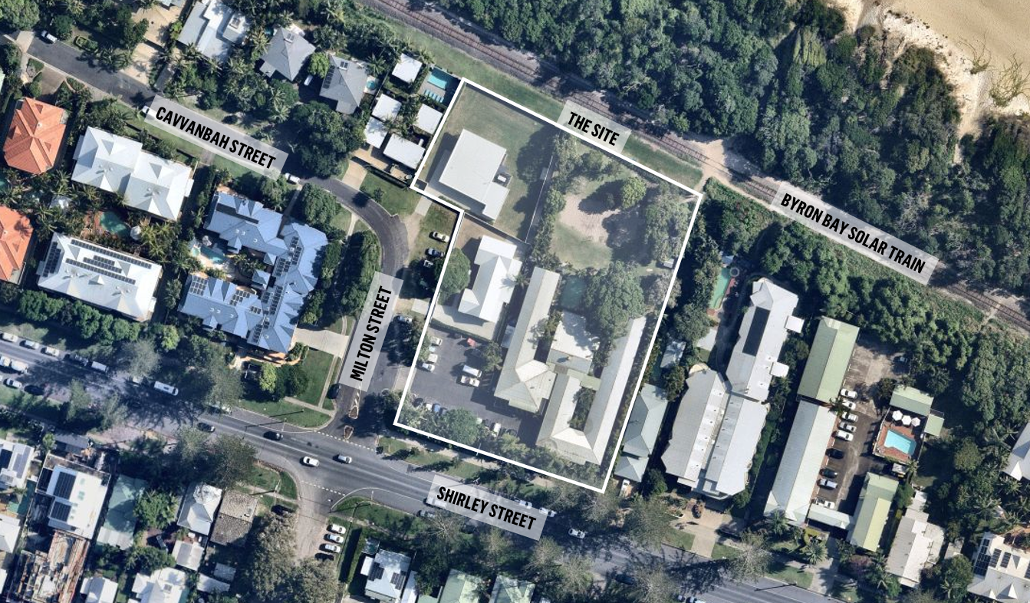
Figure 1: Site Location Source: Urbis adapted from Nearmap 2024
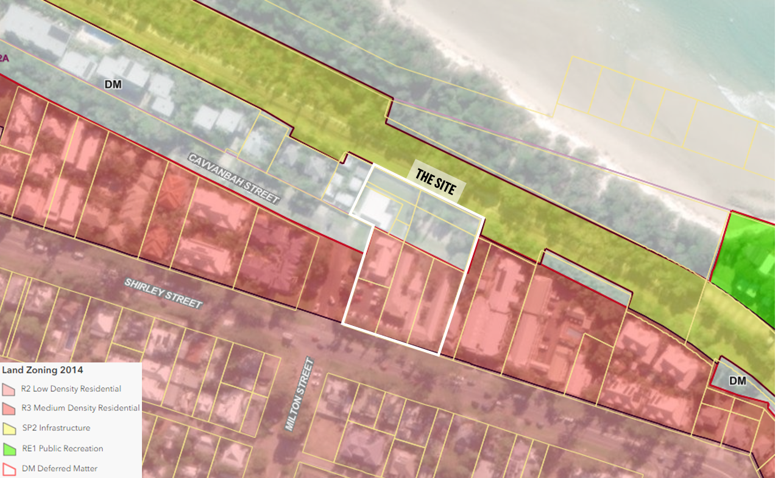
Figure 2: Zone mapping Source: Byron Shire Council Web Map 2024

  - The Locality
The site is located within Byron Bay, within the broader Northern New South Wales region, and sits approximately 400 metres from the Byron Bay Town Centre and 5.8km from the Pacific Motorway. The site sits along the eastern approach of Shirley Street, which is a key thoroughfare for vehicles travelling into Byron Bay as they exit the Pacific Highway onto Ewingsdale Road.
Within the local context, the site benefits from its proximity to the Byron Bay Town Centre, which includes bus services, retail and restaurant offerings, as well as civic services. The Town Centre is easily accessed via a wide, sealed footpath running along Shirley Street.
The site’s locality context with its surrounds is demonstrated in the below Figure 3.
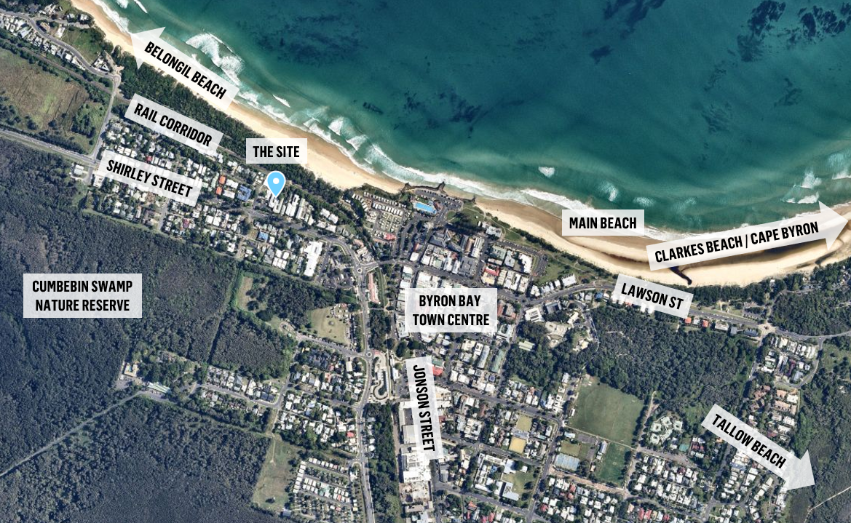 Figure 3: Source: Urbis adapted from Nearmap 2024

The following notable developments and landmarks in context to the site are as follows:
- North – immediately north, the site adjoins the rail corridor of the former Casino-Murwillumbah line. The rail corridor is still used by the Byron Bay Train, which is a solar-powered training used largely to connect tourists from the Elements of Byron Resort to the Byron Town Centre. Beyond the rail corridor, the area transitions to the coastal environment of Belongil Beach and the Pacific Ocean.
- East – the site adjoins an existing two-storey Dwelling House, positioned towards the front of the lot. Further east sits a series of two-storey resort, motel and serviced apartment developments, before the character of Shirley Street transitions through civic services, such as an aged care facility and Byron Bay Police Station. Shirley Street continues east, turning into Lawson Street as it enters the Byron Bay Town Centre.
- South – immediately south, the site fronts Shirley Street, which adjoins an area of one- to two-storey Dwelling House developments, holiday villas, and medical and allied health uses including the former Byron District Hospital. Further south sits Cumbebin Swamp and associated Nature Reserve
- West – the site adjoins the intersection of Shirley Street and Milton Street. West of the subject site and north of Shirley Street is an area largely dominated by two- to three-storey resort and hotel developments. South of Shirley Street sits a cluster of single Dwelling Houses on smaller lots, interspersed by larger lots and resort developments. Further west Shirley Street transitions to Ewingsdale Road, past the Cumbebin Swamp and associated Nature Reserve.

- THE PROPOSAL AND BACKGROUND

  - The Proposed Modification
The Section 4.55(2) Application seeks consent for the following changes:
- Reconfiguration of internal floor plans across all dwellings,
- Change in private-use pool shapes from rounded edges to square edges;
- Minor size reduction of undercover balcony/terraces on ground floor level for all ground floor units with the exception of unit 003 which has been made slightly larger;
- Sewer easement width increased from 3m to 4m;
- External façade amendments including window scheduling and screening to align with internal reconfigurations;
- 1.8m high fixed privacy screening to prevent views down to private open space of neighbouring property;
- Raised planter boxes and pools on roof tops within both zones
- Increase in total building height for the building portion situated within the R3 Medium Density Residential zone from 10.7m to 13.02m to highest lift overrun and 11.06m to top of pools and balustrades
- Increase in total building height for the building portion situated within the 7(F2) Urban Coastal Land from the 9m approved in the condition of consent to 9.7m;
- Increase of floor to floor heights for the building portion situated within the R3 Medium Density Residential zone;
- Decrease of floor to floor heights for the building portion situated within the 7(F2) Urban Coastal Land zone;
- Reconfiguration to rooftop areas across the R3 Medium Density Residential and 7(F) 2 zone.
- Reduction in basement level footprint from 3,720m2 to 3,630m2 which includes a change to the rear setback of the basement from 10m to 10.6m;
- Reconfiguration of basement level services including the fire pump room, fire services water tank, pool pump and switch room;
- Relocation of bicycle storage area within the basement level from its previous location adjacent to the main lobby, to their relocation towards the western boundary;
- Reconfiguration to the lobby area and communal facilities within the basement level to include a wellness centre;
- Staging of works; and
- Modification to conditions of consent as detailed below

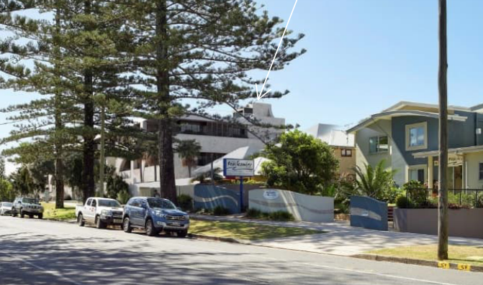
Figure 4: Proposed Lift over run and modified development as viewed from Shirley St

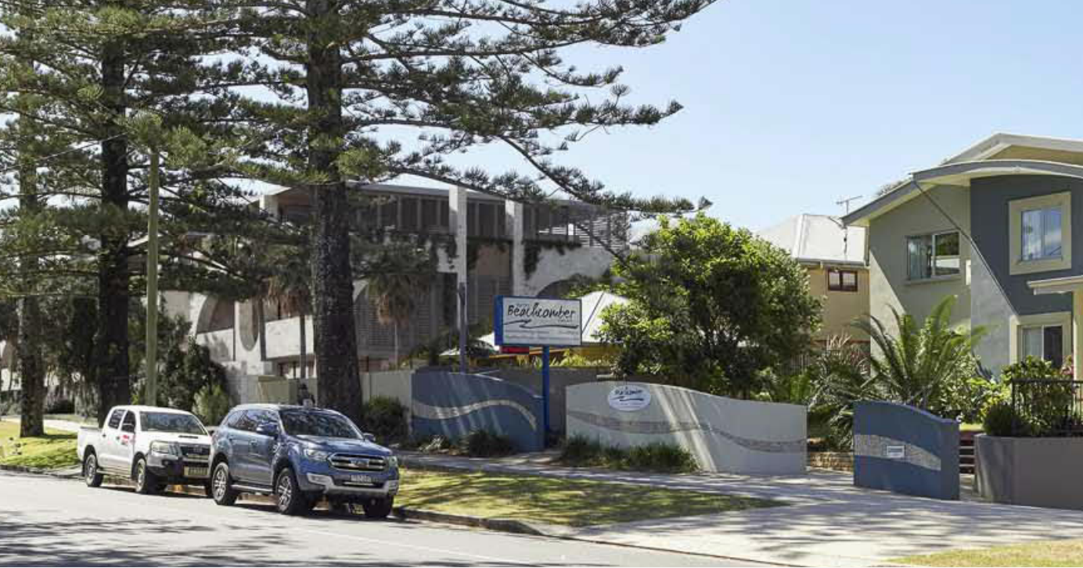
Figure 5: Existing approved development as viewed from Shirley St

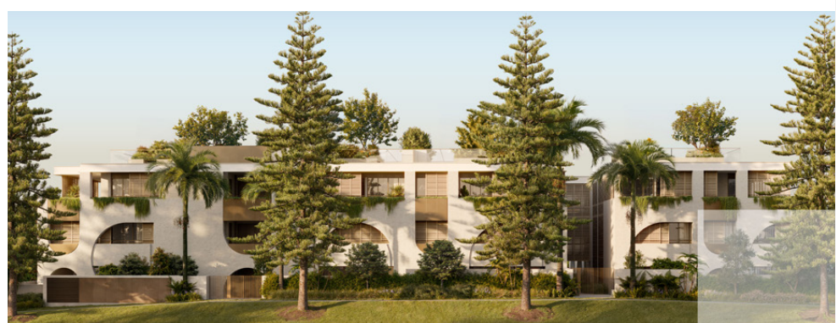
Figure 6: Proposed modified Shirley St elevation with proposed rooftop landscaping included

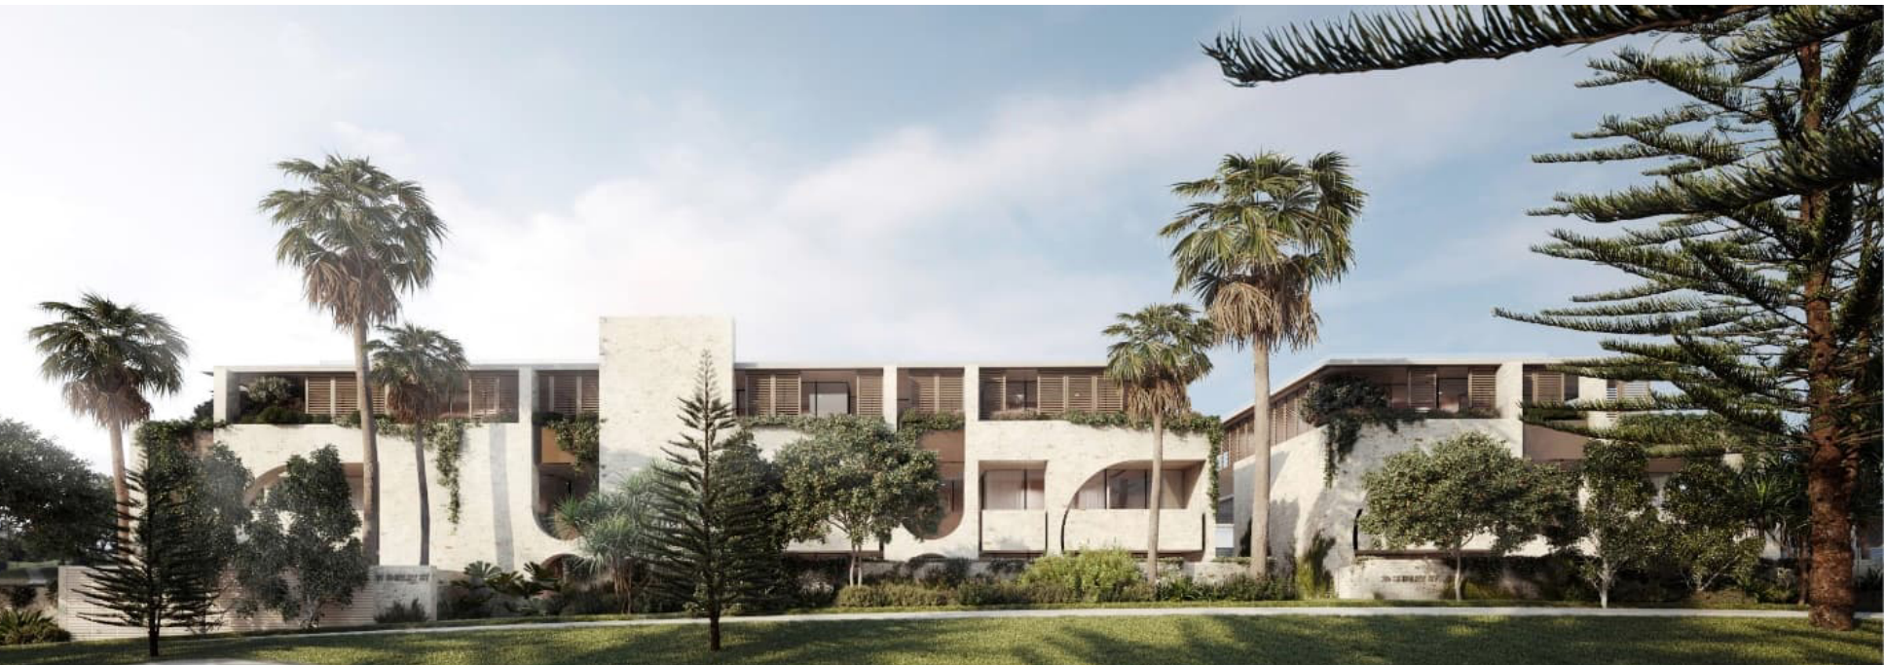
Figure 7: Approved Shirley St elevation

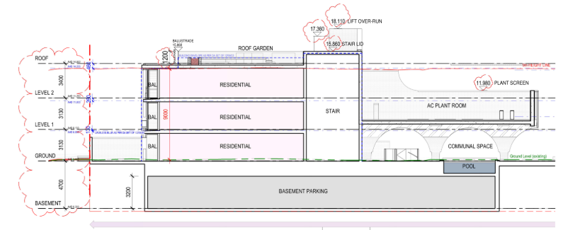
Figure 8: Proposed Section D N-S Section 1

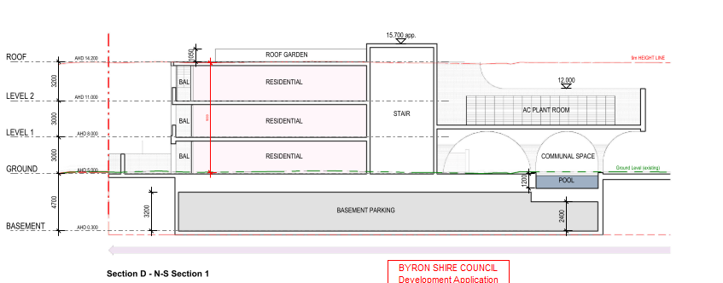
Figure 9: Approved Section D N-S Section 1

Proposed Changes to Conditions

- The application proposes changes to the following conditions:

Table 1: Proposed Changes to Conditions
Condition No | Condition requirements | Change Proposed | Reason for Change
1 | Approved plans and supporting documentation | Modify architectural plans  Modify Statement of Landscape Intent  Outcome: Supported, subject to conditions. | To reflect proposed modifications
6 | Bush fire safety measures | Revised Bush Fire Assessment Report to be listed.  Outcome: Amended Bush Fire report reviewed by RFS and supported. | To reflect modified scheme.
15 | Demolition of Existing Development  Prior to issue of construction certificate, the Applicant must obtain TfNSW’s and UGLRL’s approval for demolition of existing development. | Prior to demolition of existing development adjoining the rail corridor, being LOT: 11 DP: 1138310 & LOT: 12 DP: 1138310, the applicant must obtain TfNSW and UGLRL’s approval.  Outcome: Supported by TfNSW subject to changes below:  TfNSW have reviewed the proposal and support the condition to be modified to:  “Prior to commencement of any demolition works on Lot 11 DP 1138310 and Lot 12 DP 1138310 which are adjacent to the rail corridor, the applicant must obtain TfNSW and UGLRL’s approval for demolition of existing development. “ | To enable demolition to commence on parts of the site which will not impact the rail corridor
25 | Traffic Management Plan (TMP)  Prior to issue of the construction certificate, consent from Council must be obtained for a Traffic Management Plan (TMP) pursuant to Section 138 of the Roads Act 1993. The plans and specifications are to include the measures to be employed to control traffic (inclusive of construction vehicles) during construction of the development. The TMP is to be designed in accordance with the requirements of the current version of the Transport for NSW Traffic Control at Work Sites Technical Manual.  The report must incorporate measures to ensure that motorists using road adjacent to the development, residents and pedestrians in the vicinity of the development are subjected to minimal time delays due to construction on the site or adjacent to the site.  The TMP and associated traffic guidance scheme/s must be prepared by a suitably qualified Transport for NSW accredited person | Traffic Management Plan (TMP)  Prior to issue of Construction Certificate (CC1), consent from Council must be obtained for a Traffic Management Plan (TMP) pursuant to Section 138 of the Roads Act 1993. The plans and specifications are to include the measures to be employed to control traffic (inclusive of construction vehicles) during construction of the development. The TMP is to be designed in accordance with the requirements of the current version of the Transport for NSW Traffic Control at Work Sites Technical Manual.  Outcome: Supported by Council’s Development Engineer. | There are 2 TMP’s required – 1 for early civil works and 1 for construction. The Early Works TMP is required as part of the Section 138 process.
26 | S.88E Public Positive Covenant to be placed on title – Coastal erosion  Documentary evidence is to be provided to the Principal Certifying Authority that a public positive covenant, pursuant to the provisions of S.88E of the Conveyancing Act, 1919, has been placed on the title to the land, the subject of this consent, stating:-  The development granted via development consent number 10.2022.371.1 must cease if at any time the coastal erosion escarpment comes within 50 metres of the building subject of the consent. The development the subject of this consent must be demolished immediately, and the landowner must suitably revegetate the land.  In this covenant coastal erosion escarpment means the landward limit of erosion in the dune system caused by storm waves.  Please note: Documents requiring the endorsement of Council associated with the creation or cancellation of easements, restrictions, covenants are subject to fees listed within Council’s Fees & Charges. | S.88E Public Positive Covenant to be placed on title – Coastal erosion  Prior to the issue of construction certificate Stage 4 (CC3), documentary evidence is to be provided to the Principal Certifying Authority that a public positive covenant, pursuant to the provisions of S.88E of the Conveyancing Act, 1919, has been placed lodged- on the title to the land, the subject of this consent, stating:-  The development granted via development consent number 10.2022.371.1 must cease if at any time the coastal erosion escarpment comes within 50 metres of the building subject of the consent. The development the subject of this consent must be demolished immediately, and the landowner must suitably revegetate the land.  In this covenant coastal erosion escarpment means the landward limit of erosion in the dune system caused by storm waves.  Outcome: Supported subject to changes below:  Council’s Development Engineer supported the proposed changes to construction certificate however the deletion of placed to lodged is not supported. | To align with proposed staging
27. | Fibre-ready Facilities and Telecommunications Infrastructure  Prior to the issue of the Construction Certificate in connection with a development, the developer (whether or not a constitutional corporation) is to provide evidence satisfactory to the Certifying Authority that arrangements have been made for:  - the installation of fibre-ready facilities to all individual lots and/or premises in a real estate development project so as to enable fibre to be readily connected to any premises that is being or may be constructed on those lots. Demonstrate that the carrier has confirmed in writing that they are satisfied that the fibre ready facilities are fit for purpose; and  - the provision of fixed-line telecommunications infrastructure in the fibre-ready facilities to all individual lots and/or premises in a real estate development project demonstrated through an agreement with a carrier.  (Note real estate development project has the meanings given in section 372Q of the Telecommunications Act). | Prior to the issue of the Construction Certificate (CC2) in connection with a development, the developer (whether or not a constitutional corporation) is to provide evidence satisfactory to the Certifying Authority that arrangements have been made for:  a) the installation of fibre-ready facilities to all individual lots and/or premises in a real estate development project so as to enable fibre to be readily connected to any premises that is being or may be constructed on those lots. Demonstrate that the carrier has confirmed in writing that they are satisfied that the fibre ready facilities are fit for purpose; and  b) the provision of fixed-line telecommunications infrastructure in the fibre-ready facilities to all individual lots and/or premises in a real estate development project demonstrated through an agreement with a carrier.  Outcome: Council’s Development Engineer reviewed and supported the modification, subject to the wording below:  Fibre-ready Facilities and Telecommunications Infrastructure  Unless exempted from Part 20A of the Telecommunications Act 1997, evidence satisfactory to the Certifying Authority must be submitted prior to the issue of the Construction Certificate Stage 3 (CC2) in connection with a development, that the developer (whether or not a constitutional corporation) has made arrangements for:  - the installation of fibre-ready facilities to all individual lots and/or premises in a real estate development project so as to enable fibre to be readily connected to any premises that is being or may be constructed on those lots. Demonstrate that the carrier has confirmed in writing that they are satisfied that the fibre ready facilities are fit for purpose; and  - the provision of fixed-line telecommunications infrastructure in the fibre-ready facilities to all individual lots and/or premises in a real estate development project demonstrated through an agreement with a carrier.  Notes:  - real estate development project has the meanings given in section 372Q of the Telecommunications Act; and  - exemptions only apply if published on the Register of developments exempted from Part 20A of the Telecommunications Act 1997 issued by the NSW Government Department of Infrastructure, Transport, Regional Development, Communications and the Arts, or similar. | To align with proposed staging
28 | Land to be consolidated  All separate parcels of land are to be consolidated into one allotment and registered with NSW Land Registry Services.  Prior to issue of the construction certificate, proof of lodgement to NSW Land Registry Services must be provided to the Principal Certifying Authority. | All separate parcels of land are to be consolidated into one allotment and registered with NSW Land Registry Services.  Prior to issue of the construction certificate (CC3), proof of lodgement to NSW Land Registry Services must be provided to the Principal Certifying Authority.  Outcome: Supported  Council’s ET Engineer requires the condition to be modified to prior to Stage 1 CC1. | To align with proposed staging
31. | Sewer Easements - Section 88B Instrument  A Section 88B Instrument and one (1) copy are to be submitted to Council. The final plan and accompanying Section 88B Instrument are to provide for:  - Sewer Easements  The creation of easements for drainage of sewage over all sewage pipelines and structures located within the proposed allotments in accordance with the Policy: Building in the Vicinity of Underground Infrastructure 2020.  The minimum width of the required easement shall be 4 metres centred over the pipeline. | Prior to the issue of construction certificate (CC3), a Section 88B instrument and one (1) copy are to be submitted to Council. The final plan and accompanying Section 88B Instrument are to provide for:  - Sewer Easements  The creation of easements for drainage of sewage over all sewage pipelines and structures located within the proposed allotments in accordance with the Policy: Building in the Vicinity of Underground Infrastructure 2020.  The minimum width of the required easement shall be 4 metres centred over the pipeline.  Outcome: Supported subject to the below:.  Council’s ET Engineer requires the condition to be modified to prior to Stage 1 CC1. | To align with proposed staging
32. | Certificates for engineering works  The submission of all test certificates, owners manuals, warranties and operating instructions for civil works, mechanical and/or electrical plant, together with a certificate from a suitably qualified engineer certifying that all works have been constructed in accordance with the approved plans and Council’s current “Northern Rivers Local Government Design and Construction Manuals and Specifications”. | Certificates for engineering works  “For all works relating to a Section 138, prior to the issue of an Occupation Certificate (OC) the submission of all test certificates, owners manuals, warranties and operating instructions for civil works, mechanical and/or electrical plant, together with a certificate from a suitably qualified engineer certifying that all works have been constructed in accordance with the approved plans and Council’s current “Northern Rivers Local Government Design and Construction Manuals and Specifications.”  Outcome: Unsupported.  Council’s Development Engineer does not support any change to the wording. The condition is recommended to be moved to under the heading ““The following conditions are to be complied with prior to occupation of the building”. | No reason noted by applicant
52 | Traffic Management Plan  The approved traffic management plan is to be implemented. | The approved traffic management plans are to be implemented. | There are 2 TMP’s required – 1 for early civil works and 1 for construction. The Early Works TMP is part of the Section 138 process.
54 | Toilet facilities  Toilet facilities are to be provided, at or in the vicinity of the work site at the rate of one toilet for every 20 persons or part of 20 persons employed at the site. Each toilet provided must be a toilet connected to an accredited sewage management system approved by the Council or be a building and construction site portable chemical toilet.  Only one (1) such portable chemical toilet may be used during construction, should additional toilets be required during the construction they must be either:  - Connected to an accredited sewage management system approved by the Council. or  - Not installed or used until such time that approval under Section 68 of the Local Government Act 1993 is obtained for the installation of a human waste storage facility.  Note: The chemical toilet must be installed and serviced by a licensed contractor (including pump-outs) | Toilet facilities are to be provided, at or in the vicinity of the work site at the rate of one toilet for every 20 persons or part of 20 persons employed at the site. Each toilet provided must be a toilet connected to an accredited sewage management system approved by the Council or be a building and construction site portable chemical toilet.  Outcome: Unsupported. Council’s Building Surveyor does not agree with modifying this condition. A s68 for the temporary additional toilets is required. | The existing wording relating to one (1) portable chemical toilet to be used during construction will contravene WHS obligations per the Building Code of Australia (BCA). As per the BCA, the following is extracted:  “The facilities must be clean and hygienic. Where it is not reasonably practicable to provide access to permanent toilets, portable toilets need to be provided (clause 47). These must be installed securely, and be provided with a lockable door, lighting and ventilation.”  Per Clause 51 of the BCA:  “Toilets need to be accessible, preferably located inside a building or as close as possible to the workplace, to eliminate or reduce any risk to employee safety while accessing them. In multi-storey buildings, toilets need to be located on at least every second storey. For short-term temporary workplaces and workplaces in remote areas, a temporary toilet needs to be provided in a secure place with safe access.”  The Development site is a large in area, greater than 6,000 sqm, has an extensive basement and 3 levels above. There will be times when a large workforce will be on site and potentially spread out between a lower basement and higher levels. As per Clause 51, the construction phase will need to have toilets:  “as close as possible to the workplace, to eliminate or reduce any risk to employee safety while accessing them. In multi-storey buildings, toilets need to be located on at least every second storey.”
50. | Sequencing of Works  Before the commencement of any earthworks on site, all road and stormwater upgrading works in Milton St (south) must be constructed in accordance with the engineering plans required by this consent and the Roads Act consent.  Certification that all works (road & stormwater) in Milton St (south) has been constructed in accordance with the engineering plans and Work-As-Executed (WAE), prepared by a suitably qualified engineer, together with a final completion letter from Council for the Roads Act works, must be submitted to the Principal Certifying Authority prior to the issue of construction certificate. | The purpose of the condition is to ensure that stormwater works in particular are completed to enable the conveyance of any groundwater that is encountered during the excavation of the basements for the development.  Outcome: Supported  There is no specific objection to enabling demolition and sheet piling to occur earlier then foreseen and as such it is recommended that condition 50 be amended to read:  Sequencing of Works  Before the commencement of any dewatering on site, all road and stormwater upgrading works in Milton St (south) must be constructed in accordance with the engineering plans required by this consent and the Roads Act consent.  Certification that all works (road & stormwater) in Milton St (south) has been constructed in accordance with the engineering plans and Work-As-Executed (WAE), prepared by a suitably qualified engineer, together with a final completion letter from Council for the Roads Act works, must be submitted to the Principal Certifying Authority prior to the issue of the Stage 2 construction certificate (CC1.1.) | The applicant made a late request to amend condition 50 to enable sheet piling to occur following demolition of the existing buildings on the site.  Condition 50 of the consent requires a range of civil works to be completed prior to construction works being completed.

Proposed New Conditions:
Condition | Wording | Reason
Staging of Construction Certificates | “Prior to commencement of any construction works associated with the approved development, it is mandatory to obtain a Construction Certificate. Plans, specifications and relevant documentation accompanying the Construction Certificate must include any requirements imposed by the conditions of this Development Consent.  It is acknowledged that the developer intends to obtain staged Construction Certificates generally in accordance with the following;  CC1 - Piling and Shoring  CC1.1 - Basement excavation including dewatering and retention  CC3 – Construction of structure including services;  CC4 – Completion of works, landscaping and public art;  Conditions within this Development Approval should be read as being applicable to the relevant Construction Certificate and to be confirmed by the Principle Certifying Authority.”  Outcome: Supported, subject to changes.  Council’s building Surveyor supports staging of the CC, however undertaking demolition works without required conditions being satisfied is not supported.  New condiitions banner after parameters named ”Prior to any demolition works commencing” is recommended and any existing demolition conditions relocated to under this banner.  Recommended wording of condition:  Staged Development  The development is to be carried out in the following stages:  Stage 1 (CC1): Piling and Shoring  Stage 2 (CC1.1): Basement excavation including dewatering and retention  Stage 3 (CC2): Construction of basement including in-ground services up to the underside of ground floor;  Stage 4 (CC3): Construction of structure including services  Stage 5 (CC4): Completion of remaining works and landscaping  Where conditions are required to be satisfied prior to a particular event, those conditions are the conditions relevant to the works being carried out in the stage.  The relevant conditions are the conditions deemed necessary, by the Principal Certifying Authority (PCA) appointed for the development, or, where pursuant to the issue of a Construction Certificate, the relevant consent authority.  Refer to condition of consent 6A. | The proposed staging of works will allow for flexibility in appropriately delivering each component of the staged build in accordance with particular approval conditions, specifically in the delivery of basement excavation works and services.

Table 2: Development Data
Control | Approved | Modification Proposal
Site area | 5,937 sqm
  No change
FSR  R3 Zone  (0.6:1 permitted) | 0.66:1 approved | No change proposed.  It is noted the original FSR calculation did not include any area of the basement.  As per the definition of Gross Floor Area within BLEP 2014, the oversupply of 12 parking spaces is to be included.  The inclusion of these spaces brings the FSR to 0.69:1, however there is increase to the floor areas currently approved. No further consideration required.
Density 7(f) 2 zone  (8.2 dwelling permitted) | 10 Dwellings approved | No change proposed
Clause 4.6 Requests  BLEP 2014 | Maximum Building Height  FSR | Maximum Building Height  FSR
Clause 64A Requests  BLEP 1988 | Maximum building height | Maximum building height
No of apartments | 25 x 3 bedroom dwellings | 25 dwellings with reconfigured layouts
Max Height  R3 Medium Density zone | Southern building – adjoining corner of Shirley & Milton streets  - 9.2m (RL14.2) to the top of the roof level approved  - 10.25m (RL 15.25) to the top of the balustrade approved.  - 10.7m (RL15.7) to the top of the lift overrun and fire staircase approved. | Southern building – adjoining corner of Shirley & Milton streets  - 9.89m (RL14.66) to the top of the roof level proposed. This results in a maximum non-compliance of 0.89m.  - 11.1 m (RL 15.95) to the top of the rooftop pool and 15.836 to top of balustrade. This results in a maximum non-compliance of 2.1m.  - 13.05m (RL18.110) to the top of the lift overrun. This results in a maximum non-compliance of 4.05m.
Maximum Height  7(f)2 zoning | Northern building – adjoining rail corridor  9m maximum height approved in condition of consent no. 9 | Northern building – adjoining rail corridor  - 9.7m (RL13.9) to the top of the balustrade, pool and planter box. This results in a maximum non-compliance of 0.7m.
Landscaped area | 1,392m² of communal landscaping including 527.32m² of deep soil zones | 1,437.24m² of landscaping including 551m² of deep soil zone
Car Parking spaces | 69 car parking spaces including 7 visitor parking | No Change proposed
Setbacks | - Building 1 adjoining Milton Street 1.7m to terrace and 5.7m to façade. Adjoining Shirley Street 5.145m to terrace and 6.735 to façade.  - Building 2 adjoining Shirley Street 5.145m to terrace and 6.735 to façade. Adjoining eastern boundary 4.0m to terrace and 5.350m to façade.  - Building 3 adjoining Milton Street / western boundary 5.8m to balcony and 9.3m to façade.  - Building 4 adjoining eastern boundary 4.5m. Adjoining northern boundary / rail corridor 6.6m to terrace and 9.9m to façade. Adjoining western boundary 4.8m. | No change proposed to above ground setbacks.  Basement setback adjoining the rail corridor proposed to be increased from 10m to 10.6m

  - Background

The original development consent was granted on 16 October 2023, with the key issues considered in the assessment of the original development comprising the following:

- Stormwater Management
The initial architectural scheme proposed its legal point of discharge towards the rail corridor. Following further discussions with Council and Transport for New South Wales (TfNSW) in relation to concerns of stormwater impacts on the rail corridor to the north, properties downstream of the corridor and the dune environment of Belongil Beach, new stormwater management infrastructure was incorporated within the scheme to discharge stormwater to the south of the site to avoid any impacts to the rail corridor. Therefore, the approval in its current form does not discharge stormwater into the rail corridor. No changes to the approved development are proposed in this regard as part of the current s4.55(2) request.

Clause 4.6 Variation Request in the R3 Zone - Height
The development application sought a height variation of 1.7m, resulting in a maximum approved height of 10.7m , equivalent to a variation of 18.9%. The height exceedance was to facilitate the top of the lift overrun, fire staircase and rooftop balustrading. The exceedance was justified, supported and approved. Further increases to the height exceedance are proposed as part of this s4.55(2) request.

Clause 64A Variation Request in the 7(f2) Zone
The development application sought a variation to the height of the building by an additional 1.1m in exceedance of the 9m, equivalent to a variation of 13.9%. The height exceedance was to facilitate the top of the lift overrun and fire staircase.
Further, the Clause 64A request also sought to propose a third floor level of units which was not supported and amended within a revised development scheme to comply with the maximum of 2 floor levels permitted within the 7(f2) zone. Ultimately, a maximum height of 9m within the 7(f2) zone was approved via condition of consent No. 9.

Further increases to the height exceedance are proposed as part of this S4.55(2) request.

Clause 4.6 Variation Request in the R3 Zone – Floor Space Ratio
The development application sought a variation to the floor space ratio of the development by an additional 208.4m² of GFA, equating to a 0.66:1 FSR.
No material change to the FSR is proposed as part of the current modification request.

Density within the 7(f2) Zone
The development application initially sought approval for a total of 26 dwellings, with 14 of these located within the 7(f2) zoning. To achieve compliance, a reduction of density within the 7(f2) zoning was sought from a total of 14 to 10 units approved. No changes to the density is proposed as part of this s4.55(2) request.

Building Height Plane encroachment
The development application sought a minor variance to the building height plane provision (D1.2.1) for the minor encroachment of balcony areas within the eastern setback (4m setback to boundary) and balcony areas within the western setback (4.8m setback to boundary). During the previous assessment process, Council considered this variation to be minor and consistent with the relevant objectives and supporting performance criteria. No changes to the building height plane are proposed as part of this s4.55(2) request.

Proximity to Escarpment
The development application sought a building footprint that would be located approximately 80m from the Belongil coastal escarpment, as identified within the mapped Erosion Precinct 2. Given the site’s separation distance from the escarpment line and the presence of the railway corridor further to its northern boundary, a development condition of consent was imposed to restrict the future land use on the site should the escarpment come within 50m of the future building. The approved setbacks are retained in the current s4.55 request.

Vegetation Clearing
The approved development includes the removal of existing vegetation in order to facilitate the extent of the development, including a Moreton Bay Fig tree, subject to appropriate compensatory landscaping. No changes to vegetation removal is proposed as part of the s4.55 request.

The proposed modification application was lodged on 24/07/2024. A chronology of the modification application since lodgement is outlined below in Table 3 including the Panel’s involvement (briefings, deferrals etc) with the application:

Table 3: Chronology of the Modification Application
Date | Event
24 July 2024 | Modification application lodged
05/08/24 to 25/08/24 | Exhibition of the application
29 July 2024 | Modification referred to RFS
3 September 2024 | Request for Information from Council to applicant (Cl 104 of the 2021 Regulation)
16 September 2024 | Further amended modification plans lodged by applicant increasing the maximum building height in the R3 zone, increased private open space areas, increased basement setback to the east.
23 September | Amended plans and documents received from applicant in response to Council’s Request for Information Request dated 03/09/24.
03 October 2024 | Amended Visual Impact Statement received from Applicant
14 October 2024 | Modification referred to TfNSW
22 October 2024 | Panel briefing
4 November 2024 | Further amended modification plans lodged by applicant removing the proposed gate access onto the railway corridor, dated 01/11/24, accepted by Council under Cl 113(1) of the 2021 Regulation on 8/11/24.
5 November to 18 November | Re - exhibition of the modified plans and documents
8 November 2024 | Request for Information from Council to applicant (Cl 104 of the 2021 Regulation)
15 November 2024 | Amended plans and documents received from applicant in response to Council’s Request for Information Request dated 03/09/24.

  - Site History

The site is composed of 10 lots, each with the following history of development.

All lots:
Application number | Description | Status | Date
10.2022.371.1 | Demolish existing development and clear the site, including existing buildings and trees to facilitate a residential flat building development comprising of 25 three-bedroom dwellings distributed across four separate two and three-storey buildings with basement car parking, associated landscaping and amenities | Approved | 18/10/2023

Lot 8 Section 52 DP758207
Application number | Description | Status | Date
5.1986.437.1 | Swimming pool | Finalised | 31/01/1987
5.1986.437.1 | Proposed New Holiday Guest Lodge | Finalised | 31/01/1986

Lot 9 Section 52 DP758207

Application number | Description | Status | Date
22.2021.12.1 | Development advice panel – Demolition of existing buildings and construction of 21 dwellings | Finalised | 02/12/21
Lot 7 DP841611

Application number | Description | Status | Date
10.2000.584.1 | Commercial development – Motel | Approved | 17/03/2001
17.2001.7059.1 | Modification to amend DA 10.2000.584.1 additions of sinks to mini bars | Withdrawn | 25/2001

Lot 1 DP582819

Application number | Description | Status | Date
10.2004.735.1 | Medium density development (4x 1 bedroom and 2 x 2-bedroom units) | Deferred (approved) | 01/08/2007
10.2022.115.1 | Swimming pool | Approved | 06/07/2022

Lot 1 DP780935

Application number | Description | Status | Date
80/2504 | Alterations | Unknown | 21/10/1980
6.1990.2503.1 | Veranda additions (alterations and additions to dwelling) | Finalised | 13/01/1990
10.2004.735.1 | Medium density development (4x 1 bedroom and 2 x 2-bedroom units) | Deferred (approved) | 01/08/2007
10.2022.116.1 | Swimming pool | Approved | 06/07/2022

Lot 8 DP841611

Application number | Description | Status | Date
10.2004.735.1 | Medium density development (4x 1 bedroom and 2 x 2-bedroom units) | Deferred (approved) | 01/08/2007
10.2022.116.1 | Swimming pool | Approved | 06/07/2022

Lot 9 DP841611

Application number | Description | Status | Date
10.2004.735.1 | Medium density development (4x 1 bedroom and 2 x 2-bedroom units) | Deferred (approved) | 01/08/2007
10.2022.116.1 | Swimming pool | Approved | 06/07/2022

Lot 11 DP1138310
Application number | Description | Status | Date
10.2020.47.1 | Alterations and additions to existing Tourist facility in Two (2) stages | Approved | 14/10/2022

- STATUTORY CONSIDERATIONS

When determining a modification application, the consent authority must take into consideration the matters outlined in 4.55(2) of the EP&A Act in relation to modification of consents provisions, Section 4.15(1) of the EP&A Act in relation to matters for consideration for applications and Part 5 of the 2021 EP&A Regulation in relation to information requirements and notification. These matters are considered below.

  - Section 4.55 of the EP&A Act

A consent authority may, on application being made by the applicant or any other person entitled to act on a consent granted by the Northern Regional Planning Panel and subject to and in accordance with the regulations, modify the consent if a number of matters are satisfactorily addressed pursuant to Section 4.55(2) of the EP&A Act. The matters include the following:

- It is satisfied that the development to which the consent as modified relates is substantially the same development as the development for which consent was originally granted and before that consent as originally granted was modified (if at all) (s4.55(2)(a)), and

The proposed floor plan layout changes, increase in building heights due to lift overruns, intensive rooftop activation, rooftop pools and rooftop landscaping substantially alter the approved development and results in significant changes to the amenity and built form.

The proposed modification application as a whole, if approved, would result in the modification not being substantially the same as the development for which consent was originally granted.

Council recommends the modification is supported, subject to a 2 part recommendation. The recommendation will result in the development being substantially the same for which the consent was originally granted. Refer to Key Issues section.

- It has consulted with the relevant Minister, public authority or approval body (within the meaning of Division 4.8) in respect of a condition imposed as a requirement of a concurrence to the consent or in accordance with the general terms of an approval proposed to be granted by the approval body and that Minister, authority or body has not, within 21 days after being consulted, objected to the modification of that consent (s4.55(2)(b)), and

The proposal is not integrated development.

- it has notified the application in accordance with—
- the regulations, if the regulations so require, or
- a development control plan, if the consent authority is a council that has made a development control plan that requires the notification or advertising of applications for modification of a development consent (s4.55(2)(c)), and

Notification was undertaken in accordance with the Council’s Community Participation Plan, Division 2 of Part 5 of the 2021 EP&A Regulation.

- it has considered any submissions made concerning the proposed modification within the period prescribed by the regulations or provided by the development control plan, as the case may be (Section 4.55(2)(d)).

The modification application was notified between 5 August 2024 and 25 August 2024 and renotified on 5 November 2024 to 18 November 2024. 1 submission was received. The issues raised in these submissions are considered in Section 4 of this report.

- In determining an application for modification of a consent under this section, the consent authority must take into consideration such of the matters referred to in section 4.15 (1) as are of relevance to the development the subject of the application. The consent authority must also take into consideration the reasons given by the consent authority for the grant of the consent that is sought to be modified (Section 4.55(3)).

The matters required to be considered include:

- Matters for consideration pursuant to Section 4.15(1) of the EP&A Act – these matters are considered below in Section 3.2 of this report; and

- Reasons given by the consent authority for the grant of the consent that is sought to be modified – outlined below.

Reasons for Grant of Consent

The NORTHERN REGIONAL Planning Panel granted consent to the original development in a notice of determination dated 16 October 2023 The reasons outlined in the Statement of reasons for this decision included the following:

REASONS FOR THE DECISION

The Panel agreed with Council's assessment that:
- the development is permissible with consent in both relevant zones: namely R3 Medium Density
- under BLEP 2014 and the 7(f2) Urban Coastal Land zone under BLEP 1988,
- the proposal is generally consistent with the SEPP 65 Design Quality Principles and satisfies the requirements and objectives of the relevant controls,
- the development, subject to the recommended conditions, will not result in unacceptable adverse impacts upon the natural or built environments, and
- the development is consistent with the objects of the Environmental Planning and Assessment Act 1979.

In respect of the R3 Medium Density Residential land, the Panel agrees that:
- exceedance of the height and floor space ratio controls under BLEP 2014 are justified,
- the proposed exceedances are minor and will enable additional dwellings consistent with the R3 zoning and existing medium density character fronting the northern side of Shirley Street, and
- The FSR exceedance is also justified as it enables improved landscape and communal open space outcomes across that portion of the site.

In respect of the Deferred Matter - 7(f2) Urban Coastal Land, the Panel:
- agreed that the provision of 10 dwellings across two floors is acceptable, noting this is a minor exceedance of the minimum site area per dwelling ratio of 300m2 of site area for each dwelling greater than 85m2 in floor area under BDCP 2010 Chapter 1 Part C.7.2 for residential flat buildings.
- The proposed density (resulting in 10 dwellings vs 8.2 dwellings under the DCP control) is considered acceptable because the building mass is contained in one uniform level structure surrounded by generous landscaping and open space and subject to the height control issue (see below) will result in a development not out of character with the typical lower form, bulk and amenity of development on adjoining 7(f2) Urban Coastal Land, and
- is not satisfied the request to exceed the cI. 40 (2)(b)(ii) height control is justified. The Panel agrees with Council that the 4m floor to ceiling heights proposed for the residential floors could be reduced to have the uppermost roof level (including parapets and balustrades) conform with the height control and still provide adequate internal spaces, and
- concluded that, subject to all building elements including balustrading conforming with the 9m height control, and submission of adequate landscape designs, accessible rooftop gardens with modest trafficable areas are acceptable and will have insignificant adverse amenity or environmental impacts.

The proposed supported modification, as detailed in Council’s 2 part recommendation will remain consistent with these reasons for the decision.

  - Section 4.15(1) of the EP&A Act

Section 4.15(1) of the EP&A Act contains matters which the consent authority must take into consideration in determining a development application and modification applications pursuant to Section 4.55(3) which are of relevance to the application.

These matters include the following, which are considered in detail below:

- the provisions of—
- any environmental planning instrument, and
- any proposed instrument that is or has been the subject of public consultation under this Act and that has been notified to the consent authority (unless the Planning Secretary has notified the consent authority that the making of the proposed instrument has been deferred indefinitely or has not been approved), and
- any development control plan, and
(iiia) any planning agreement that has been entered into under section 7.4, or any draft planning agreement that a developer has offered to enter into under section 7.4, and
- the regulations (to the extent that they prescribe matters for the purposes of this paragraph),
that apply to the land to which the development application relates,
- the likely impacts of that development, including environmental impacts on both the natural and built environments, and social and economic impacts in the locality,
- the suitability of the site for the development,
- any submissions made in accordance with this Act or the regulations,
- the public interest.

    - Section 4.15(1)(a) - Provisions of Environmental Planning Instruments, Proposed Instruments, DCPs, Planning Agreements and the Regulations

The relevant provisions under s4.15(1)(a) are considered below.

- Environmental planning instruments (s4.15(1)(a)(i))

The following Environmental Planning Instruments are relevant to this application

- State Environmental Planning Policy (Building Sustainability Index: BASIX) 2004
- State Environmental Planning Policy (Housing) 2021 (Previously SEPP 65)
- State Environmental Planning Policy (Planning Systems) 2021
- State Environmental Planning Policy (Resilience and Hazards) 2021
- State Environmental Planning Policy (Transport and Infrastructure) 2021
- Byron Local Environmental Plan 2014
- Byron Local Environment Plan 1988
- Byron DCP 2014
- Byron DCP 2010;

A summary of the key matters for consideration arising from these State Environmental Planning Policies are outlined in Table 4 and considered in more detail below.

Table 4: Summary of Applicable State Environmental Planning Policies (Preconditions in bold)
EPI | Matters for Consideration | Comply (Y/N)
SEPP BASIX 2004 | An updated BASIX Certificate 1288442M_03 was submitted. The updated NatHERS certificate no. submitted does not match that shown on the BASIX certificate. The NAtHERS stamped plans submitted do not match the DA plans submitted. | N  Refer to Key Issues
State Environmental Planning Policy (Sustainable Buildings) 2022 | This policy does not apply as the modification was submitted after 1 October 2023, and saving provisions apply under s4.2(f). | N/A
State Environmental Planning Policy (Housing) 2021  (previously in SEPP 65) | Design Quality Principles – Some of the proposed modified internal unit layouts are contrary to the design quality principles for Built form & scale and Amenity. The proposal is contrary to the ADG requirements for apartment layout. | N  Refer to Key Issues
State Environmental Planning Policy (Planning Systems) 2021 | Chapter 2: State and Regional Development  - Section 2.19(1) declares the proposal regionally significant development pursuant to Clause 2 of Schedule 6 as it comprises development that has a capital investment value of more than $30 million. | Y
SEPP (Resilience & Hazards) | Chapter 2: Coastal Management  - Section 2.7(4) – The development is not in coastal wetlands or littoral rainforest on the Coastal Wetlands and Littoral Rainforests Area Map  - Section 2.8(1) – The development is not on land in proximity to coastal wetlands or littoral rainforest.  - Section 2.10(1) & (2) - Development is not on land within the coastal environment area  - Section 2.11(1) - Development is on land within the coastal use area but will not have an adverse impact on the coastal use area. This is assessed below.  - Section 2.12 - Development in coastal zone generally —the development does not increase the risk of coastal hazards.  - Section 2.13 - Development in coastal zone generally – there are no certified coastal management program that apply to the land.  Chapter 4: Remediation of Land  Section 4.6 - Contamination and remediation has been considered in the documentation provided with the application which has been reviewed by Councils EHO. The proposal is considered satisfactory subject to conditions. | Y
State Environmental Planning Policy (Transport and Infrastructure) 2021 | Chapter 2: Infrastructure  - Section 2.48(2) (Determination of development applications—other development) – electricity transmission – no change proposed  - Section 2.119(2) – The development has frontage to Shirley Street which is classified road. However, it will not be accessed off Shirley Street. The application was previously reviewed by TfNSW and considered satisfactory. No changes proposed.  - Section 2.120(2) Impact of road noise or vibration on non-road development. Shirley Street has traffic volumes greater than 20k VPD. Impacted dwelling units can be acoustically treated to achieve the required dB(A) levels.  - Section 2.121(4) – The proposal is not a Traffic-generating development.  Section 2.98 Development adjacent to rail corridors  Proposed modification reviewed by TfNSW and considered satisfactory. | Y
Proposed Instruments | No proposed instruments relevant to the proposal | Y
LEP | BLEP 2014 and BLEP 1988 apply to the site. The development is permitted with consent in both zones and achieves the objectives of both zones, subject to conditions of consent.  Clause 4.6 and 64A variation requests have been made for additional height. The variation to height in both zones is not supported. These are assessed in detail below. | N  Refer to Key Issues
DCP | BDCP 2014 & BDCP 2010 apply to the site. No changes to approved minor variations to BHP, fence heights and setbacks are proposed. These are supported because the development otherwise achieves the relevant objectives and supporting performance criteria. These matters are assessed in detail below. Conditions of consent are recommended. | Y

Consideration of the relevant SEPPs is outlined below:

- State Environmental Planning Policy (Sustainable Buildings) 2022
This policy does not apply as the modification was submitted after 1 October 2023, and saving provisions apply:
Section 4.2 Savings and transitional provisions.
- an application for modification of a development consent under the Act, section 4.55 or 4.56 submitted on the NSW planning portal on or after 1 October 2023, if the development application for the development consent was submitted on the NSW planning portal before 1 October 2023.
Thus SEPP (BASIX) 2004 must be taken into consideration.

- State Environmental Planning Policy (BASIX) 2004.
The objectives of this Policy are to ensure that the performance of the development satisfies the requirements to achieve water and thermal comfort standards that will promote a more sustainable development.

The modification application is accompanied by an updated BASIX Certificate No.1288442M_03 prepared by ADP Consulting dated 07 June 2024 committing to environmentally sustainable measures. The updated NatHERS certificate provided by the applicant does not match the BASIX certificate The NatHERS stamped plan set does not match the modification set. Without a valid NatHERS certificate and NatHERS stamped plans set, Council cannot be satisfied the modified development demonstrates the relevant water, thermal and energy commitments as required by the BASIX SEPP.

Condition of consent recommended for updated BASIX and NATHERS to be provided prior to construction certificate.

- State Environmental Planning Policy (Housing) 2021
Chapter 4 Design of residential apartment development

Section 147 development consent must not be modified unless the consent authority considers
        - The quality of the design of the development as set out in Schedule 9
        - The Apartment Design Guide

Based on the following assessment of the modified development against Schedule 9 and the Apartment Design Guideline it is concluded that the proposal does not achieve compliance with the relevant provisions of the SEPP.

It is considered the proposed modification to building height and internal apartment layouts are not consistent with Principle 2 built form and scale and Principle 6 Amenity, for the reasons outlined below. It is recommended conditions of consent relating to building height and internal layout are imposed to ensure consistency.

PRINCIPLE | ASSESSMENT OF DESIGN RESPONSE
Principle 1: Context and Neighbourhood Character | Shirley Street is part of the main ‘gateway;’ entrance to Byron town. The northern end of Shirley Street is characterised by a rapidly evolving mix of visitor and medium density residential developments on landscaped sites. Stand-alone dwellings are being displaced by developments which have maximised the opportunities of the R3 Medium Density Residential Zone. The proposed modified development, with proposed conditions of consent reducing the maximum building height to a predominantly complying 9m, will sit appropriately within this evolving context, with its emphasis on articulated vertical built form surrounded by subtropical native landscaping and open space. Overall, the buildings are well designed responding to and enhancing the qualities and identity of the area including the adjacent sites and streetscape. The site is within easy walking distance from Byron town centre and its services. This is a positive outcome for the supply of medium density residential living options and the sustainability of Byron town centre.  Adjacent development across Shirley Street to the south are lower rise, more reflective of the lower density zoning and the controls of the Shirley Street Heritage Conservation Area. The proposed development is consistent with this evolving juxtaposition. Shirley Street itself features an avenue of scheduled Norfolk Island Pine Trees, in various states of maturity and wide often elevated berm areas that provide an ideal pedestrian environment. The modified development will complement this public realm with buildings to be conditioned to be predominantly limited in height to a complying 9 metres, landscaping, articulated building facades and quality finishes. The development will not impact the Norfolk Island Pines.
Principle 2: Built Form and Scale | The proposed maximum building height of 13.05m in the R3 zone and 9.7m in the 7F2 zone is not appropriate to the existing or desired future character of the street and surrounding buildings.  Recommended conditions of consent for maximum building heights to remain as approved in DA10.2022.371.1. This will ensure appropriate built form and scale.  The buildings fronting Shirley and Milton Streets, will remain effectively set back and utilise façade articulation, materiality, and landscaping to reduce the perception of over dominant scale from the streetscape.  The development, with conditions of consent to restrict the height, will achieve an appropriate built form with consideration to the site’s topography and boundary restrictions. The development and its built form outcome are inclusive of articulation throughout the design. This is done using façade design and finishes, building separation and landscaped open space.
Principle 3: Density | No change to density is proposed.  The development retains an acceptable density relative to the site and its context.
Principle 4: Sustainability | The development includes extensive landscaped open space as a core design principal and deep planting areas for groundwater recharge and vegetation.  All apartments will benefit from a north-east aspect in the morning hours.  A BASIX certificate was provided, however a valid NatHERS Certificate is required to confirm the development will meet the NSW Government’s requirements for sustainable design. Refer to Key Issues.
Principle 5: Landscape | The development effectively integrates open space, landscaping and built form. Overall, the maximization of height, façade articulation, and building separation creates an outcome where vertical built elements are surrounded by open space, landscaping, and other ground level amenities. This is enabled by the use of below ground parking. The development incorporates 551m2 of deep soil landscaping. Landscaping has also been extensively used to enhance amenity outcomes between the development, adjoining properties and the public realm streetscape.
Principle 6: Amenity | The modified dwelling floor plans of apartments 005 to 009 and 105 to 109 include study and habitable rooms with no access to external windows or ventilation resulting in poor amenity and design outcome. Conditions of consent recommended. Refer to Key Issues.  Dwellings have screened views to neighbouring properties to maintain privacy to adjoining lots and increase amenity.  All dwellings will have lift access and levelled outdoor living areas to internal spaces to facilitate ease of access for all age groups and degrees of mobility. The proposed development complies with BDCP 2014 Chapter B13: Access and Mobility.
Principle 7: Safety | The proposed development optimises safety and security within the development and in relation to Shirley / Milton Streets and the rail corridor. This is achieved by passive overlooking from decks and living spaces etc. Private open space areas are generously dimensioned, appropriately orientated and therefore fit for purpose.  Access points are well defined and will be legible for residents, visitors, and pedestrians.
Principle 8: Housing Diversity and Social Interaction | The proposed development incorporates 3-bedroom units which the applicant believes will meet local market demand for this unit typology with generous floor area.  Byron Bay is experiencing continued intense demand for housing supply. By providing 25 x 3 bedroom well serviced medium density units the proposed development actively addresses this demand.  The development provides substantial communal open space for all future residents and visitors etc to promote and allow for social interaction.
Principle 9: Aesthetics | The development presents a built form that has appropriate proportions surrounded by extensive open space and landscaping. This will create positive visual amenity for residents, adjoining properties and when viewed from the public realm. The development incorporates brick masonry walls, screening elements to facilitate dappled light, access of sea breeze, and privacy for residents. The development utilises materials for doors, windows, frames and timber decking with tones and colours that complement the building.

Assessment against Apartment Design Guide (ADG)
The SEPP requires consideration of the ADG which supports the associated design quality principles by giving greater detail as to how those principles might be achieved. The assessment below considers the proposal against key design criteria in the ADG and it is considered the modification does not comply with 4D Apartment Layout. Conditions of consent recommended to ensure compliance.

Element | Compliance
4B:  Natural Ventilation | Modification remains compliant  Plans submitted show that appropriate cross-ventilation is provided for. This is achieved through openable walls to balconies which allow for breezes through each unit.  The proposal satisfies the requirements and objectives of this control.
4C:  Ceiling Heights | Modification remains compliant.  The development will incorporate minimum floor to ceiling heights of 2.7m. These high ceilings enhance cross-ventilation and sunlight penetration. The development is not mixed-use or commercial therefore flexible reuse is not anticipated.  The proposal satisfies the requirements and objectives of this control.
4D:  Apartment layout | The modified plans indicate that apartment sizes remain compliant with required dimensions.  However, the proposed amendment to the floor plan layouts of apartments 005 to 009 and 105 to 109 include new habitable rooms noted as either a study, or room name left blank, with no direct external windows or daylight. The layout is not considered to be functional and reduces the high standard of amenity.  The proposal does not satisfy the requirements and objectives of this control. Refer to Key Issues.
4O:  Landscape design | Modification remains compliant.  Proposed landscaping features extensive compensatory native landscaping suited to the local environment and balanced against fire safety constraints. Landscaping is therefore considered to be viable and sustainable. Landscaping is key to the developments effective interfacing with the public realm and will enhance the streetscape as well as contributing to amenity for occupants.  Landscape scale and design is also pivotal to the evident overall design concept of vertical built elements surrounded by and set in an open space and landscaped environment.  The proposal satisfies the requirements and objectives of this control.

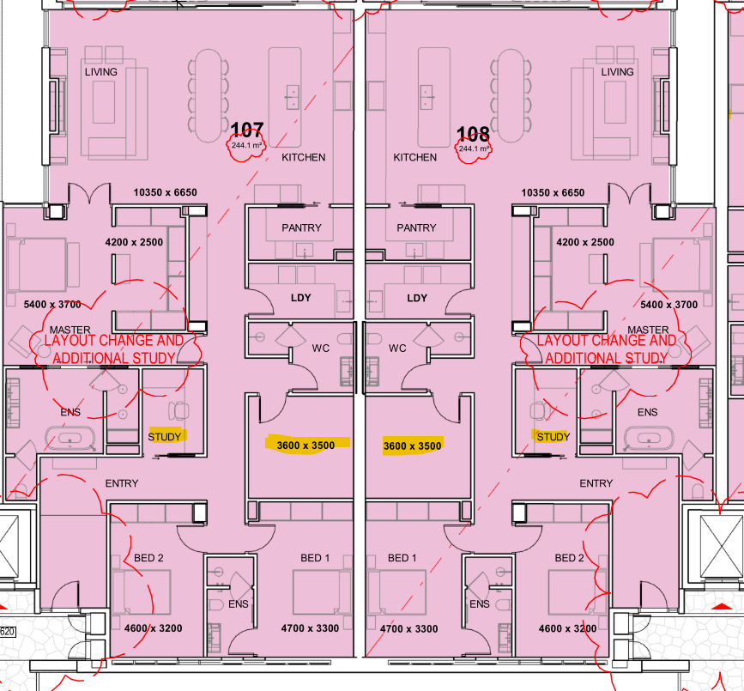

Figure 10: Proposed modified habitable rooms highlighted

Section 148 (2)- The modified development will remain compliant with the non discretionary provisions of:
(a) car parking for the building is greater than the recommended minimum amount specified in Part 3J of Apartment Design Guide
(b) the internal area for each apartment is greater than the recommended minimum internal area for the apartment type specified in Part 4D of the Apartment Design Guide
(c) the ceiling heights for the building are equal to the recommended minimum ceiling height specified in Part 4C of Apartment design Guide.

- State Environmental Planning Policy (Planning Systems) 2021 (‘Planning Systems SEPP’)

Chapter 2: State and Regional Development
The proposal is regionally significant development pursuant to Section 2.19(1) as it satisfies the criteria in Clause 2 of Schedule 6 of the Planning Systems SEPP as the proposal is development for a Residential Flat Building. Accordingly, the Northern Regional Planning Panel is the consent authority for the application. The proposal is consistent with this Policy.

- State Environmental Planning Policy (Resilience and Hazards) 2021

Chapter 4: Remediation of Land

The provisions of Chapter 4 of State Environmental Planning Policy (Resilience and Hazards) 2021 (‘the Resilience and Hazards SEPP’) have been considered in the assessment of the development application. Section 4.6 of Resilience and Hazards SEPP requires consent authorities to consider whether the land is contaminated, and if the land is contaminated, it is satisfied that the land is suitable in its contaminated state (or will be suitable, after remediation) for the purpose for which the development is proposed to be carried out.
Council’s Environmental Health Officer has reviewed the modification, raised no concerns. Existing conditions of consent in relation to contamination to remain.

- State Environmental Planning Policy (Transport and Infrastructure) 2021
Section 2.98 required consent authorities to consider the likely impact of development on land adjacent to a rail corridor. A referral was sent to TfNSW who raised no concerns, subject to the imposition of conditions of consent.

- Applicable Local Environmental Plans

The site is mapped partially as 7 (f2) Urban Coastal Land zoning under the Byron Local Environment Plan 1988 (BLEP 1988) and partially in R3 Medium Density Residential under the Byron Local Environment Plan 2014 (BLEP 2014). The following is an assessment of the application against both LEP’s.

BLEP 2014

Zoning and Permissibility (Part 2)

The map below details the zoning of the site.

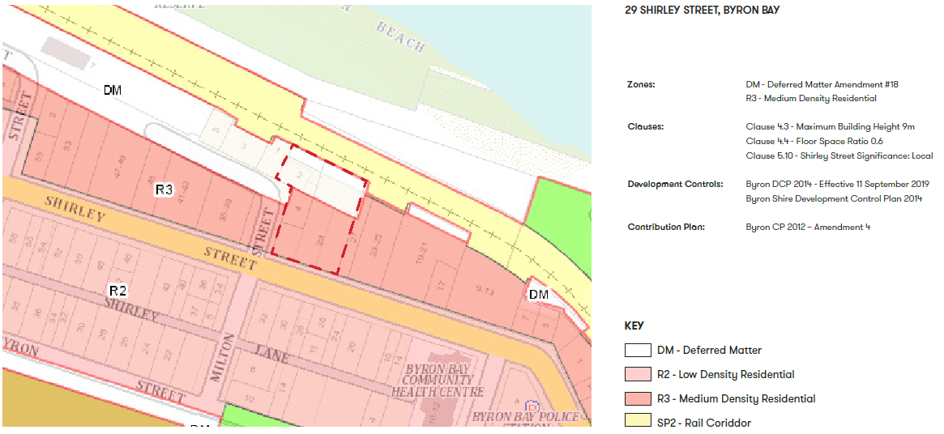

BLEP 2014 Permissibility, zone objectives, relevant clauses and s4.6 variation assessment.

In accordance with LEP 2014 clauses 1.4 and 2.1 – 2.3:
(a) The proposed development is defined as residential flat building in the BLEP 2014 Dictionary, meaning a building containing 3 or more dwellings, but does not include an attached dwelling, co-living housing or multi dwelling housing.
(b) Part of the land is within the R3 Medium Density Residential zone according to the Land Zoning Map;
(c) The proposed development is permissible with consent; and
(d) Regard is had for the Zone Objectives as follows:
Clause 2.3 Zone Objective | Assessment
To provide for the housing needs of the community within a medium density residential environment. | By providing twenty-five three-bedroom dwelling units the proposed development will contribute to providing for the housing needs of the community within a medium density residential environment.
To provide a variety of housing types within a medium density residential environment. | The proposed development will contribute to providing a variety of housing types within a medium density residential environment
To enable other land uses that provide facilities or services to meet the day to day needs of residents. | Other than residential, no other land uses are proposed within this development

General Controls and Development Standards (Part 2, 4, 5 and 6)

The LEP also contains controls relating to development standards, miscellaneous provisions and local provisions. The controls relevant to the proposal are considered in Table 5 below. Non compliance with clauses are considered in the key issues section of this report

Table 5: Consideration of the LEP Controls
Control | Requirement | Approved | Modification Proposal | Comply
Height of buildings  (Cl 4.3(2)) | 9 metres |  | 13.05m | No  Refer to key Issues
FSR  (Cl 4.4(2)) | 0.6:1 | 0.66:1 | No change | N  No changes proposed
Variation Request  (Cl 4.6) | - | Variation request to height and FSR | Variation request to height.  Refer to detail assessment below. | No  Refer to key issues
Heritage  (Cl 5.10) | The development site is across the road from the Shirley Street Heritage Conservation Area and therefore within the vicinity of a heritage conservation area | Heritage Management Report provided | Council is satisfied that the effect of the proposed development modification on the heritage values of the Shirley Street Heritage Conservation Area will be less than minor and therefore acceptable. | Yes
Acid sulphate soils  (Cl 6.1) | development consent must not be granted for the carrying out of works unless an acid sulfate soils investigation management plan (ASSIMP) has been prepared in accordance with the Acid Sulfate Soils Manual. Previously assessed | Previously assessed and conditions of consent applied | Conditions of consent to remain | Yes
Earthworks  (Cl 6.2) | consent authority to consider the effects of the proposed development on the environment and surrounding area because of any proposed earthworks. | Council’s development Engineer and EHO, conditions of consent are recommended concerning earthworks, sedimentation and erosion controls and dewatering management. | Council’s Environmental Health Officer and Development Engineer reviewed the modified proposal and recommended conditions of consent | Yes
Stormwater Management (Cl 6.4) | Previously assessed | Previously assessed and conditions of consent applied. | No change proposed | Yes
Essential Services  (Cl 6.6) | consent authority to be satisfied that essential services are available for the proposed development | Previously assessed and conditions of consent applied. | No change proposed | Yes

Written requests to vary development standards are not required for s4.55 applications, however the reasoning for the original approval of a variation to the height of buildings is considered as follows:
Clause 4.6 Exceptions to Development Standards
Where a DA includes a variation to a development standard, an application under Clause 4.6 Exceptions to Development Standards of the LEP is required.
Clause 4.6 provides that development consent must not be granted for development that contravenes a development standard unless the consent authority has considered a written request from the applicant that seeks to justify the contravention of the development standard, by demonstrating that compliance with the development standard is unreasonable or unnecessary in the circumstances of the case, and that there are sufficient environmental planning grounds to justify contravening the development standard.

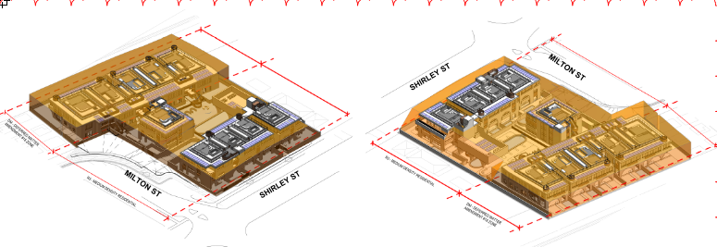
Figure 11: Height encroachments

The application seeks variations to Clause 4.3 Height of Buildings, assessed as follows;

The site is subject to a 9m maximum building height which is equivalent to a 2 to 3-storey building. Prior to this modification application, the previous application (reference: DA.10.2022.371.1) sought a variation of the height control for a maximum exceedance of 1. 7m, equivalent to a variation of 18.9%.

The architectural scheme as part of the submitted s4.55(2) package included a proposed maximum building height of 11.21 m for the buildings proposed within the R3 zoned portion of the site, equivalent to a variation of 24.56%.
The addition of the lift shaft extent as included within the further amended package results in a total building height of 13.05m within R3 zoned land. This is an equivalent increase of 45% above the 9m building height line.

The applicant provided the following written request.
It is considered that the following environmental planning grounds are sufficient to justify the non- compliances with the development standard proposed:
- The non-compliance facilitates a high quality and consistent built form across the Site's Street frontages to Milton and Shirley Streets. The topography of the Site and existing ground levels, defined by the current development on the Site and fall from east to west dictate that a consistent and level built from at the eastern edge of the Site will become non-compliant at the corner of Shirley and Milton Street simply as a result of the existing ground level.

- The minor non-compliance provides for an improved planning outcome by facilitating the consistent floor levels and building frontage addressing Shirley Street. In circumstances where strict compliance was required the building would need to step and create odd breaks in order to provide strict compliance.
- Such a design would be inefficient, uneconomical and provide for a poor streetscape outcome and address. It is considered that the minor non-compliances attributable to the existing ground level on Site provides for a superior planning outcome and is sufficient to justify the extent of non-compliance proposed.
- The majority of non-complaint elements of the proposal are attributable to the balustrade and minor building elements on roof top private open space. These elements are barely perceptible from the streetscape and facilitate the delivery of high quality and high amenity private open space for occupants of the development. The delivery of such high-quality open space relieves pressure on communal areas within the development by providing private space for occupants at the upper levels of the building and it is considered the increased amenity and relieving of pressure on common areas is a planning ground which is sufficient to justify the minor breaches to the height control proposed.
- The contravention of the development standard arises as a result of the redistribution of the buildings GFA to create more open space on the ground plane. In order to provide high quality and spatially generous areas of common open space at ground level the building proposes to accommodate the floor area of the proposed development across 3 storeys which results in minor and inconsequential non- compliance with the HOB standard. The provision of the high quality landscaped open space at ground level provides for a superior planning outcome both spatially, in terms of built form, and also in terms of amenity for future occupants. It is considered that the provision of high quality open space at ground level is a material planning benefit associated with the non-compliance and offsets the imperceptible impacts associated with the technical non-compliance of the upper portion of the building.

Having regard to the minor building elements which contravene the 9m control, their extent and context within the overall built form, including lack of any material environmental impacts associated with them, it is considered that the above planning grounds and demonstrable benefits associated with the areas of breach to the height control proposed are sufficient to justify the non-compliance.

Assessing Planners Comments
Maximum Building Height R3 zone
 | Approved | Proposed
Top Roof | 9.2m (RL14.2) | 9.8m
Top balustrade | 10.25 (RL 15.25) | 11.2m
Top Lift Overrun | 10.7m (RL 15.7) | 13.05m

Figure 12: Visual render of Shirley St elevation demonstrating the visual impact of rooftop structures.

The approved development consent DA10.2022.371.1 considered strict compliance with the development standard was considered unreasonable and unnecessary in the circumstances and a maximum height of 10.7m to the top of the lift over run and fire staircases, and 10.25m to the top of balustrades was approved.

It is considered there are insufficient environmental grounds to further increase the height exceedance and vary the development standard for the following reasons:

- The proposed development significantly exceeds the maximum height control of 9m from existing ground level to finished roof or parapet. The proposed height exceedances involve the majority of the roof structure, rooftop balustrades, lift overruns, roof top pools, roof top planter boxes and landscaping and terraces. These elements will be able to be seen from the street frontage and will impose unacceptable visual and amenity impacts on the surrounding area. Refer figure 12.
- The scale and cumulative impacts of the roof top elements are likely to compromise the amenity of neighbouring dwellings by the visual impact, potential loss of privacy, and incompatibility with the streetscape.
- The lift overrun to unit 201, results in a height exceedance of 4.05m. The lift is not justified as it only services the rooftop of one unit (unit 201), a staircase is available to access the rooftop and the height exceedance of 4.05m proposes an unacceptable visual impact on the locality.
- The height exceedance is not demonstrated to provide any better amenity outcomes. The proposed modified floor to ceiling heights of the ground and first floor are 3130mm, and 3400 for level 2. These floor heights can be effectively reduced to still provide a finished floor to ceiling height of 2.7m on each level without resulting in any design or amenity impacts, whilst resulting in a built form that complies with the objectives of the zone.

Conclusion:

As assessed above the application does not demonstrate that compliance with the development standard is unreasonable and unnecessary.

As assessed above the application demonstrates that there are insufficient environmental planning grounds to justify contravening the standard.

It is recommended that the variation to the maximum height development standard remain as approved on the development consent 10.2022.371.1 and not be varied further.

BLEP 1988 Zone objectives, relevant clauses and s64A variation assessment.
In accordance with LEP 1988 clauses 5, 8 and 9:
(a) The proposed development is defined in the LEP 1988 Dictionary as residential flat building(s);
(b) The land is within the LEP1988 7(f2) zone according to the map under LEP 1988;
(c) The proposed development is permitted with development consent ; and
(d) The proposed development is on balance consistent with the relevant objectives of the Zone for the following reasons:
Part 2.9 Zone Objectives | Assessment
Zone No 7 (f2) - (Urban Coastal Land Zone)  1 Objectives of zone  The objectives of the zone are—  (a) to identify urban land likely to be influenced by coastal processes,  (b) to permit urban development within the zone subject to the council having due consideration to the intensity of that development and the likelihood of such development being adversely affected by, or adversely affecting, coastal processes,  (c) to permit urban development within the zone subject to the council having due consideration to—  (i) the need to relocate buildings in the long term,  (ii) the need for development consent to be limited to a particular period,  (iii) the form, bulk, intensity, and nature of the development, and  (iv) continued safe public access to the site, and  (d) to allow detailed provisions to be made, by means of a development control plan, to set aside specific areas within the zone for different land uses and intensities of development. | 1 (a) The site, and therefore the proposed development is identified as being likely to be influenced by coastal processes based on mapping in the BDCP 2010 / BLEP 1988. The site is located within the BDCP 2010 mapped ’50-year impact line’ band or Erosion Precinct 2. See Image below.  (b) There is the potential that the development will be adversely affected by, or affect, coastal processes. However, the applicant has confirmed that they will accept conditions of consent ensuring that if the coastal escarpment comes within 50m of the development footprint, the consent will cease, and all buildings will be removed, and that a section 88E instrument be imposed on the title to this effect.  (c) (i) & (ii) The development is not relocatable, noting also that it is not a Class 1 building. Condition of consent ensures that if the ‘coastal escarpment’ comes within 50m of the development footprint, the consent will cease, and all buildings will be removed. A section 88E restriction on title is also conditioned.  (c) (iii) When considering the form, bulk and intensity of the proposed development in the 7(f2) zoned area of the site it is noted that BDCP 2010 Chapter 1 Part C.7.2 controls the dwelling density of ‘Residential Flat Buildings’ “To give effect to the objectives of zone No 7(f2)”. This objective is supported by Prescriptive Measure which set a minimum site area ‘per dwelling’ ratio of 300m² of site for each dwelling greater than 85m² in floor area.  The 7(f2) zoned area of the site is approximately 2,450m². All proposed dwelling units are greater than 85m². Based on the above ratio 8.2 dwellings would be permitted.  Ten (10) dwellings were approved and considered acceptable. No change to density proposed.
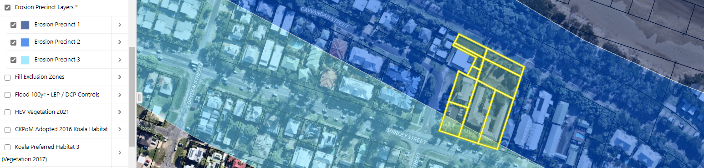
Image above shows location of site in Erosion Precinct 2

General Controls and Development Standards

The controls relevant to the proposed modification are considered in Table 5 below.

Table 5: Consideration of the LEP Controls
Control | Requirement | Approved | Modification Proposal | Comply
Height of buildings  (Cl 40) | Council must not consent to the erection of any building—  (b) on land within any other zone (in this case 7(f2) , if—  (i) the floor of the topmost floor level of the building exceeds 4.5 metres above the existing ground level, or  (ii) the vertical distance between the topmost part of the building and the existing ground level below exceeds 9 metres. | Condition of consent imposed requiring maximum height of 9m. | Architectural plans show the maximum height proposed of approximately 9.7m. | No  Refer to Key Issues
Provision of Services  (Cl 45) | - | - | No change | Y
Variation Request  (Cl 64A) | - | Variation request to height not approved.  Variation request to density approved | Variation request to height.  No change to density proposed | N  Refer to assessment below.

Clause 64A Exceptions to Development Standards
The application is supported by a BLEP 1988 Clause 64A variation request which seeks to vary the height of building control prescribed within clause 40(b) of BLEP 1988 and the associated Height of Buildings Map.
The height control which is the subject of this Clause 64A Variation Request states:
40 Height
(1) The objectives of this clause are as follows
(a) to achieve building design that does not exceed a specified maximum height from its existing ground level to finished roof or parapet,
(b) to ensure that the height and scale of development is appropriate to its location, surrounding development and the environmental characteristics of the land.
(2) The council must not consent to the erection of any building—
(a) on land within Zone No 3 (a), if -
(i) the floor of the topmost floor level of the building exceeds 7.5 metres above the existing ground level, or
(ii) the vertical distance between the topmost part of the building and the existing ground level below
exceeds 11.5 metres, or
(b) on land within any other zone, if—
(i) the floor of the topmost floor level of the building exceeds 4.5 metres above the existing ground level, or
(ii) the vertical distance between the topmost part of the building and the existing ground level below exceeds 9 metres.
There is no definition of ‘existing ground level’ in the BLEP 1988. For this variation request the definition of ground level (existing) contained in the Standard Instrument LEP is used as follows: ‘ground level (existing) means the existing level of a site at any point’
The application seeks to vary prescribed height controls as follows. See elevations and description below.
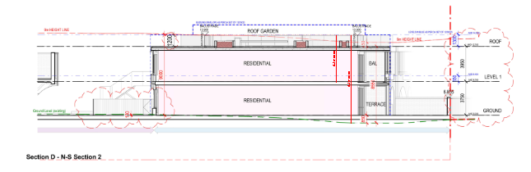
Figure 13 : Proposed Maximum Height in 7F2 zone

The applicant submitted it is considered unreasonable to require strict compliance with cl 40(b){i) as:

1. It would be unreasonable to require strict compliance with cl 40(b){i) in circumstances where the majority of the development across the consolidated site will provide for contemporary
residential levels and ceiling heights.

The development application proposes a redevelopment of consolidated land for the purpose of residential accommodation marginally over 2 levels in the 7(f2) Zone. The proposal is seeking minor height variations in relation to the overall building height to allow for balustrades to be provided at roof top level.

2. It would be unreasonable to require strict compliance with the standard contained at cI40(b)(ii) in circumstances where the topography of the site is undulating, and strict compliance would require a contorted and inefficiently stepped building in order to comply.

There is a large sand sports field located centrally within the northern portion of the site which has been excavated to create a depression in the site levels. The extent of the depression is approximately 0.5M below surrounding ground levels. It would be unreasonable to require strict compliance with the height control in circumstances where development on the sunken level would create partially subterranean residential accommodation and would result in a built form with a maximum height above the surrounding ground levels of 2m.

It would be reasonable to take account of retaining walls and ground level on adjacent properties to determine the natural ground plane across this area of the site. Effectively this would result in a general level across the northern portion of the site of approximately 4.9m AHD.

The applicant submitted it is considered that the following environmental planning grounds are sufficient to justify the non- compliances with the development standard proposed:

- The non-compliance with the 9m control provided at cl 40(b)(ii) facilitates the delivery of a contemporary and consistent design across the site containing a rational floor plate and provision of a high-quality urban design and streetscape outcome. In circumstances where strict compliance with the 9m control was to be required, the building would need to provide for a stepped and staggered built form east to west to reflect the undulating and stepped topography of the Site attributable to the existing ground levels and excavation for the existing back packer development.

- The minor non compliances associated with the upper levels of the building facilitate a high quality and consistent built form outcome across the Site. The depiction of height exceedances above the 9m limitation illustrate clearly that a consistent roof level is maintained across the development however, the changes to existing ground levels across the site lead to some areas of that roof space breaching the 9m control. The non compliances ensure that a rational and consistent built form outcome is achieved across the Site.

- The minor non compliances required for the provision of lightweight building elements facilitate the high-quality streetscape outcome and consistent design across the Site, with minor non-compliant elements arising as a result of the fall of the land and existing modifications to ground level caused by the current development on site.

- The majority of non-complaint elements of the proposal are attributable to the balustrade and minor building elements on roof top private open space. These elements are barely perceptible from the streetscape and facilitate the delivery of high quality and high amenity private open space for occupants of the development. The delivery of such high-quality open space relieves pressure on communal areas within the development by providing private space for occupants at the upper levels of the building and it is considered the increased amenity and relieving of pressure on common areas is a planning ground which is sufficient to justify the minor breaches to the height control proposed.

- The contravention of the development standard arises as a result of the redistribution of the buildings GFA to create more open space on the ground plane. In order to provide high quality and spatially generous areas of common open space at ground level the building propose to accommodate the floor area of the proposed development across 2 storeys which results in minor and inconsequential non- compliance with the HOB standard. The provision of the high quality landscaped open space at ground level provides for a superior planning outcome both spatially in terms of built form and also in terms of amenity for future occupants. It is considered that the provision of high quality open space at ground level is a material planning benefit associated with the non-compliance and offsets the imperceptible impacts associated with the technical non-compliance of the upper portion of the building.

- The non-compliance does not adversely affect the streetscape, character, amenity or solar access of surrounding land. The area of the building which does not comply with the 9m height requirement is located at the northern, rear of the Site and does not create any overlooking, overshadowing and perception of bulk issues for neighbours or adjoining properties. The majority of any non-compliance addresses the rail corridor, the view of which will only be available by passengers of the train moving past the Site. The scale of the non-compliance is minor and accordingly, unlikely to be even perceived by those looking back at the site form the north.

- The non-compliance with the provisions of c140(b) provides for a superior development outcome on the Site which provides for an appropriate residential density which reflects the environmental capacity of the site having regard to its location, surrounding development and Site characteristics.

- The non-compliance with the development standards contained at cl 40(b) allows for the orderly and economic development of the Site by facilitating consistent floor levels, construction methodology and built form outcome across the Site. If compliance with the controls was required, the built form and building design would be disjointed and provide for oversized residential levels to the northern portion of the Site which would be unrelated to the high quality and contemporary design provided to the Milton and Shirley Street frontages.

- Adequate solar access to the surrounding sites will be maintained by the proposal.

- The area of non-compliance resulting from the height breaches will not create any unacceptable visual privacy impacts.

- The proposal is a result of broader master planning and is appropriate given its current and future context.

Assessing Planners Comments
Maximum Building Height 7 F2
 | Approved | Proposed
Top balustrade and lift over run | 9m as per condition 9(a) of consent of DA10.2022.371.1 | 9.7m

- The original development proposed a height variation of up to 10.1m and Council was not satisfied the request to exceed the cI. 40 (2)(b)(ii) height control was justified. The floor to ceiling heights proposed for the residential floors could be reduced to have the uppermost roof level (including parapets and balustrades) conform with the height control and still provide adequate internal spaces. Subsequently, condition 9(a) of the consent was imposed stating:

Maximum height of the northern building. As per the requirements of BLEP 1988 Clause 40 Height (2) (b) (ii) the vertical distance of the topmost part of the northern building, including any balustrades shall not exceed 9 metres above the existing ground level below with the floor to ceiling height on levels 1 and or 2 both reduced to achieve compliance.

The modification variation request has not raised any new environmental planning grounds than those considered in the original assessment, and as such, the request to exceed the height control remains unjustified.

As per the original assessment, it has not been demonstrated that it unreasonable or unnecessary or that there are any sufficient environmental planning grounds to justify the proposed roof top balustrades, at 0.7m above maximum height and are necessary around the roof top deck / garden areas which constitute a topmost floor level, significantly higher than 4.5m.

The floor to ceiling heights of the residential floors can be reduced to enable the uppermost roof level including balustrade to conform with the height control and still provide adequate internal spaces.

As per the original assessment, subject to all building elements including balustrading conforming with the 9m height control, and submission of adequate landscape designs, accessible rooftop gardens with modest trafficable areas will remain acceptable and will have insignificant adverse amenity or environmental impacts.

Conclusion:
It is recommended:
- Condition of consent 9(a) remain in place, to ensure the building height within 7F2 zone remains limited to 9m.
- Condition of consent 9 be amended to include:
(b) Maximum height Southern buildings in R3 zoning
The maximum height of the building for any lift over runs shall not exceed 10.7 metres above the existing ground level .
The maximum height of any other elements including balustrading, pools or rooftop planters shall not exceed 10.25 metres above the existing ground level.

(c ) Northern Building Lift Overrun and Canopy
The lift servicing the rooftop of unit 201 is not approved. Plans must be amended to remove the lift and canopy from the rooftop, with the lift terminating at Level 2.

- Provisions of any Proposed Instruments (s4.15 (1)(a)(ii))

There are no proposed instruments are relevant to the proposal.

- Provisions of any Development Control Plan (s4.15(1)(a)(iii))

The following Development Control Plans are relevant to this modification application:

- Byron Shire Development Control Plan 2014 (‘the 2014 DCP’)
- Byron Shire Development Control Plan 2010 (‘the 2010 DCP’)
- DCP 2014 is an applicable matter for consideration in the assessment of the subject development application in accordance with subsection 4.15(1) of the EP& A Act because it applies to the land to which LEP 2014 applies. The DCP 2014 Parts/Chapters that are of relevance only to the proposed modified development are addressed below:

Chapter |  |  | Compliance |  | Comment
B1 | Biodiversity |  | Yes |  | No changes proposed.
B3 | Services |  | Yes |  | No changes proposed.
B4 | Traffic Planning, Vehicle Parking, Circulation and Access |  | Yes |  | Council’s Development Engineer reviewed the proposed changes to the basement level and raised no objections. No change to number of parking spaces proposed.
Chapter B9 Landscaping |  |  | Compliance |  | Comment
B9.2.2 |  | Landscape Plans for Development Applications | Yes |  | Detailed landscape documentation has been submitted with the application, to address the requirements of these parts of the DCP. Landscape plan details include design principles, soil depths, planting selection, tree plans and a landscape maintenance schedule.  Relevant conditions are included in the recommended consent.
B9.2.3 |  | Further Requirements for more Complex Developments | Yes |  | As above.
B9.4 |  | Landscaping Residential Flat Buildings | Variation approved in original consent.  1,392m2 communal landscaping and 527.32m2 deep soil zone approved |  | Based on a dwelling size to landscape area ratio the development is required to provide 2250sqm of common landscape area with 75% of this consisting of deep soil areas.  The development proposes less than 2,250sq.m of total common landscaped areas however, the development incorporates:  - A substantial communal space of 1,437.24 sq.m within the middle of the site;  - Private balconies  - Additional landscaping throughout the private external courtyards; and  - Additional landscaping within the private roof tops  The additional landscaping within the private spaces as mentioned above addresses the above short-fall through additional private landscaping.  Given the above the proposal achieves the relevant DCP objectives and performance criteria because the landscape design provides a high-quality landscape that enhances the amenity and function of the development and provides a pleasant environment for residents that will support their physical and psychological well-being. Screen planting to street frontages and between dwelling houses and around the boundaries of the site is also a feature. This positive landscaping outcome is a result of limiting building footprints, maximising building verticality, and providing all parking and servicing in a below ground basement carpark.
B9.4.2 |  | Common Landscaped Area – Deep soil areas  Prescriptive measure - 75% of the total common landscaped area of the site must consist of deep soil areas | Variation requested. 527sqm deep soil area approved. |  | 551m2 of deep soil area proposed.  The below ground parking area, being beneath the communal space limits deep soil areas. However, the deep soil areas are proposed around the perimeter of the site allowing for larger trees. This will enhance privacy to adjoining dwellings, the developments relationship to the streetscape and compliment the articulated outward facing building facades. On balance the numerical shortfall achieves DCP objectives/performance criteria and remains supported.
B9.12.2 |  | Roof Decks and Balconies | Yes |  | Planting is proposed on roof decks and balconies. Size of roof terrace will be conditioned to be limited in size. Refer to recommended condition of consent 9(e ) and 9(f).
B9.12.4 |  | Existing Vegetation | No.  All existing vegetation approved to be cleared as part of the development. |  | No change proposed
B9.12.5.2 |  | A minimum 90% of landscaping plants to be locally indigenous. | Yes |  | A minimum 90% of plants to be locally indigenous.  Landscaping will consist of 90% native species suited to the site’s local environment.
B9.12.5.3 |  | No species listed as undesirable in Chapter B2 Preservation of Trees and Other Vegetation shall be used in landscaping on any site, and  Species listed as threatened species under the Threatened Species Conservation Act 1995 should not be used for landscaping purposes unless the genetic provenance can be demonstrated in terms of locally sourced seed stock. | Yes |  | No threatened or undesirable species are proposed to be used
12.5.5 |  | Dedicated areas for vegetable growing and the provision of edible fruit trees | Yes |  | Oversized ground floor courtyards and balcony spaces provide sufficient space for vegetable gardens, if desired by future residents
Chapter D1 Residential Accommodation |  |  | Compliance |  | Comment
D1 | Residential accommodation in Urban, Village and Special Purposes Zones |  |  |  | - D1.2.2 Setbacks from Boundaries –  No changes to above ground setbacks proposed.  - D1.6.10 Character- Design Verification Statement provided is unsatisfactory and proposed floor plan modifications and increased height built form does not contribute to the character of the local area. Refer to Key Issues
D1.2.1 | Building Height Plane (BHP)  Prescriptive measure 2m & 45° applies to all boundaries |  |  | Variation requested and approved | No change proposed
D1.2.2 | Setbacks from boundaries – prescriptive measures  Classified Road (Shirley Street) 9m.  Corner allotments and secondary roads (Milton Street) 3m. |  |  | Variation requested and approved | No change proposed
D1.2.2.4 | Minimum Setbacks for Residential Flat Buildings and Multi-Dwelling Housing – prescriptive measures  Side and rear 1.5m for single storey otherwise controlled by BHP.  3m between building on site. |  |  | Variation approved in original consent | No change proposed
D1.2.2.4 | Minimum Setbacks for Swimming Pools and Spas – prescriptive measure  1.0m from coping & 1.5m from water line to boundary. |  |  | Variation approved in original consent | No change proposed
D1.2.3 | Privacy – prescriptive measures  D1.2.3.1 Where a direct view exists into the private open space of an adjoining dwelling, the outlook from windows, landing stairs, terraces, decks and balconies must be screened by privacy screens which achieve at maximum 50% transparency, or obscured by landscaping, and  D1.2.3.2 Decks, terraces, balconies, and other external living areas within 4 metres from a side or rear boundary and with a floor level greater than 1.0m above ground level (existing) will require a privacy screen unless it can be demonstrated that there will be negligible overlooking and/or privacy impacts. |  |  | Yes | The development features the use of timber horizontal louvers to achieve privacy within both the development and towards adjoining properties. These louvers, which act as privacy screening, achieve at maximum 50% transparency.  The proposed buildings do not comprise of any decks, terraces, balconies, or other external living areas situated within 4m from the side boundaries. Regardless, the development comprises of privacy screening throughout to maintain privacy to the development and the adjoining lots.  The proposed development is therefore considered to meet the objectives and associated performance criteria of this clause and can be supported because;  1. Buildings do not unduly affect existing or future development on adjoining properties by impinging on privacy or obstructing views.  2. Buildings are designed to optimise privacy for internal and external spaces while allowing for casual surveillance of the street and other public spaces.  3. Building design is cognisant of site constraints (slope, orientation, configuration/shape) and addresses privacy accordingly.
D1.2.4 | Solar Access – prescriptive measures  - Developments 2 storeys or greater must be accompanied by shadow diagrams which demonstrate.  - a) two hours sunlight between 9am and 3pm on June 21 for private open spaces; and b) three hours of sunlight between 9am and 3pm on June 21 over a portion of their north-facing living areas (decks, living rooms, bedrooms, kitchens etc.), and  - a) two hours of sunlight to at least 50% of private open spaces between 9am and 3pm on June 21; and  b) three hours of sunlight between 9am and 3pm on June 21 over a portion of north facing living areas (decks, living rooms, bedrooms, kitchens etc.).  c) where overshadowing by existing buildings is greater than the abovementioned, sunlight is not to be further restricted.  - New dwelling design should minimise overshadowing on existing adjacent solar panels where other reasonable design alternatives are possible. |  |  | Yes | An updated shadow analysis has been provided with the application. See architectural plans attachment.  These shadow diagrams demonstrate that.  - All apartments living and outdoor private space receive a minimum of 3 hours direct sunlight between 9am and 3pm on 21 June.  - All neighbouring dwellings maintain sunlight to private open spaces and north-facing living areas between the hours of 9am and 3pm, specifically on June 21 and other specifies hours.  - Adjoining residential lots to the east and west do not have existing solar panels.  The proposed development is therefore considered to meet the objectives and associated performance criteria of this clause because: the development is designed to optimise solar access and thereby not significantly overshadow living areas (decks, living rooms, bedrooms, kitchens etc.), private open spaces and existing solar power installations of both the development site and adjoining properties.
D1.2.6 | Character & Visual Impact |  |  | Yes | The proposed modification includes an updated visual impact assessment. Review of this document and the architectural plans provided with the application confirm that the development, subject to conditions of consent limiting height and rooftop activation will:  1. Retain and enhance the unique character of Byron Shire and its distinctive landscapes, ecology, towns, villages, rural and natural areas.  2. Be a new development that respects and complements those aspects of the area’s natural and built environment that are important to its existing character.
D1.2.7 | Fences – prescriptive measures  Height of fences.  Front - 1.2m, side 1.2m within the building line setback and 1.8 metres for the remainder. Rear, 1.8m.  Corner allotments - Secondary Frontage, 1.8m.  Sight Lines at Intersections - minimum corner splay of 4m x 4m must be provided in the fence. |  |  | Variation approved in original consent. Fronting Shirley Street is generally 1.63m high.  Fronting Milton Street 1.2m high.  Minimum distance to intersection 7m. | No changes proposed except for new 1.8m acoustic fence along eastern boundary in accordance with the noise impact assessment.
D1.2.8 | Balconies |  |  | Yes | The visual character of balconies is consistent with and does not dominate the design of the buildings.
D1.2.9 | Pedestrian and cycling |  |  | Yes | 52 bike parking spaces will be provided in the basement carparking.
D1.2.11 | Energy Efficiency |  |  | Yes | An updated BASIX certificate was provided, however it was incomplete as a valid NatHERS certificate was not provided. Condition of consent recommended to ensure compliance.
D1.2.12 | Internal access between storeys in residential development – prescriptive measure  Each habitable floor of a multi-storey dwelling house must be connected by an internal staircase (garage and laundry excluded). |  |  | Yes | Architectural plans provided with the application show connections between each habitable floor, and basement carparking by internal staircases and lifts.
D1.6 MULTI DWELLING HOUSING (INCLUDING MANOR HOUSES AND TERRACES), RESIDENTIAL FLAT BUILDINGS AND ATTACHED DWELLINGS
D1.6.1 | Private Open Space Courtyards |  |  | Yes | The proposed courtyards all achieve the minimum dimension of 4m x 4m.
D1.6.3 | Deep Soil Areas  At least 25% of the site must consist of deep soil areas. |  |  | Variation approved in original consent for Deep Soil Area of 527.m2 (8.88%) | Deep soil areas of 551m2 of deep soil proposed.  The shortfall is the direct result of utilising basement parking. It is considered that this shortfall does not compromise the landscape outcomes of the site.  The requested variation remains supported.
D1.6.5 | Sound Proofing |  |  | Yes | An updated Noise Impact Assessment Report by ATP Consulting Engineers dated September 2024 was provided with the application and assessed by Council’s EHO who raised no concerns.
D1.6.10 | Character -  Prescriptive measure  To facilitate good design a Design Verification Statement will be required. In demonstrating how the built form of the development contributes to the character of the local area, the statement should articulate how it is consistent with the relevant locality narrative as contained in the applicable locality chapter in Part E of this DCP |  |  | No | An updated complete Design Verification Statement was not provided.  The architectural plans were reviewed by Council against the ADG requirements and Design Quality Principals. The assessment of them found the modified development to be inconsistent with the Design Quality, Built Form and Scale Principles, and Apartment Layout.  Refer to Key Issues

Byron Shire Development Control Plan 2010 (DCP2010)
BDCP 2010 is an applicable matter for consideration in the assessment of the application in accordance with subsection 4.15(1) of the EP& A Act because it applies to the land to which BLEP 2010 applies. It is noted that the majority of the BDCP 2010 controls applicable to the Residential Flat Building land use and other general development provisions have been superseded by the BDCP 2014, these are addressed above. Consequently, the assessment against BDCP 2010 has been limited to the site-specific controls identified below.

C7 Medium Density and Residential Flat Buildings |  | Compliance | Comment
C7.2 | Dwelling Densities in Byron Bay and Suffolk Park – Prescriptive Measure  Large (over 85m2 floor area) dwelling units require a site area per dwelling of 300sqm. | 8.2 dwellings permitted, 10 dwellings approved | No change proposed
Part J Coastal Erosion Lands
J2.2 | Precinct 2 - Between the Immediate Impact Line and the 50 Year Erosion Line | Conditions of consent applied to ensure compliance | No change proposed

The following contributions plans are relevant pursuant to Section 7.18 of the EP&A Act and have been considered in the recommended conditions (notwithstanding Contributions plans are not DCPs they are required to be considered):

- Byron Shire Developer Contribution Plan 2012 (Including Amendment 4)

This Contributions Plan has been considered and included in the recommended consent conditions.

- Water and Sewer Equivalent Tenements Policy 2022

This policy has been considered by Council’s ET Engineer and additional ETs will be applicable. Included in the recommended consent conditions.

Planning agreements under Section 7.4 of the EP&A Act (s4.15(1)(a)(iiia))

There have been no planning agreements entered into and there are no draft planning agreements being proposed for the site.

- Provisions of Regulations (s4.15(1)(a)(iv))

In relation to section 61 of the Environmental Planning and Assessment Regulation 2021, given that the proposal involves demolition of a building, a condition is recommended requiring compliance with Australian Standard AS 2601—2001: The Demolition of Structures.

    - Section 4.15(1)(b) - Likely Impacts of Development

The likely impacts of the development, including environmental impacts on both the natural and built environments, and social and economic impacts in the locality must be considered. In this regard, potential impacts related to the proposal have been considered in response to SEPPs, LEP and DCP controls outlined above and the Key Issues section below.

The consideration of impacts on the natural and built environments includes the following:

- Access and traffic – The modification application proposes no changes to approved access.

- Water/air/soils impacts – The outer edges of the site are mapped as having a possible low grade acid sulfate soil presence. The basement car park will also necessitate site dewatering and exiting building demolition may reveal site contamination. These matters were reassessed by Council’s EHO and conditions of consent recommended.

- Context and setting – Context and setting – As discussed in the SEPP 65 assessment and detailed review of the development against Councils planning instruments above, the modified development, with recommended conditions of consent applied, is appropriate in its context and setting.

- Utilities – The modification application proposed no changes to approved utilities.

- Heritage – the site is adjacent to Shirley St Heritage Conservation Area and the modified development is unlikely to impact on heritage values.

- Flora and fauna impacts – Vegetation removal to remain as approved. No further impacts result from this modification application.

- Noise and vibration – The application includes an update assessment of noise impacts, which are considered acceptable subject to conditions of consent. The noise impacts of Shirley Street and the rail corridor were originally considered as part of this assessment and no further impacts result from this modification application.

- Social impact – The modified development will generally retain a positive social impact based on its contribution to sense of place through quality architecture and its planned interface with the public realm. Its ease of pedestrian and cycle access to the Byron CBD, and local community and natural amenities should ensure an active mixing of future residents into the local community.

- Economic impact – At $47m the construction of the development will be a major contributor to Byron’s local economy. A well as the direct impact of construction the development will require ongoing maintenance and the resident community will generate a significant demand for services. The development will also contribute medium density housing supply at 25 x 3 bedroom units, bolstering Byron’s seriously constrained housing supply. The stormwater upgrade described above will make a positive contribution to the future sustainability of the local stormwater network.

- Site design and internal design – As discussed in the Design Quality assessment and the assessment against Council’s planning instruments, subject to conditions, the development is appropriate for the site.

- Construction –Potential impacts from construction remain managed by appropriate conditions of consent.

- Cumulative impacts – The recommended conditions of consent to retain approved building heights, size and hours of use of the roof top terraces with pools are likely to mitigate any cumulative negative impacts on the locality and amenity of neighbouring residences.

Accordingly, it is considered that the proposed modification will result in significant adverse impacts in the locality as outlined above.

    - Section 4.15(1)(c) - Suitability of the site

- The site is adequately serviced and satisfactorily addressed the natural hazards if bushfire and coastal erosion.
- The recommended conditions of consent to retain the approved maximum heights of the building within the R3 zone and 7(F)2 zone to predominantly 9m will fit within the existing and desired future character of the locality.

    - Section 4.15(1)(d) - Public Submissions

There was 1 submission received. This submission is considered in Section 4.3 of this report.

    - Section 4.15(1)(e) - Public interest

On balance the proposal is consistent the public interest, subject to conditions of consent.

  - Part 5 of the 2021 EP&A Regulation

There are a number of matters required to be addressed in an application for modification of development consent pursuant to Division 1, 2 and 3 of Part 5 of the 2021 EP&A Regulation. These matters are considered in Table 6 below.

Table 6: Consideration of the Requirements under the Regulation
Matter | Comment | Comply
Clause 100 Application for modification of development consent
May be made by—  (a) the owner of the land to which it relates, or  (b) another person, with the consent of the owner of the land (Cl 98(1)) | The application has been made by Urbis Pty Ltd, The Trustee for the 29 Shirley Street Trust. The consent of the owner of the land has been provided. | Y
NSW Aboriginal Land Council consent required for land owned by a Local Aboriginal Land Council (Cl 98(6)). | The land is not owned by a Local Aboriginal Land Council and consent is not required. | Y
Form approved by Planning Secretary and on portal (Cl 99). | The application has been provided in accordance with the Regulation. | Y
Applicant details (Cl 100(1)(a)) | Provided on the NSW Planning Portal (‘the Portal’). | Y
Description of the development (Cl 100(1)(b)) | Provided on the Portal and outlined in Section 2 of this Report. | Y
Address and title details (Cl 100(1)(c)) | Provided on the Portal and outlined in Section 1 of this Report. | Y
Description of the proposed modification (Cl 100(1)(d)) | Provided on the Portal and outlined in Section 2 of this Report. | Y
Whether to correct a minor error, mis-description or miscalculation, or  some other effect (Cl 100(1)(e)) | The proposed modification is to modify the original consent under Section 4.55(2) to allow modification to residential flat building including building height increase within R3 Medium Density Residential zone, building height reduction within 7(F2) Urban Coastal Land zone, and reduction to trafficable rooftop areas across all buildings and is not to correct a minor error, misdescription or miscalculation. | Y
Description of the expected impacts of the modification (Cl 100(1)(f)) | The applicant expects that the modified proposal will not cause adverse environmental, social or economic impacts.  Subject to Council’s 2 part recommendation, it is considered the modification will not cause significant impacts. | Y  Refer to Key Issues
Undertaking that modified development will remain substantially same as development originally approved (Cl 100(1)(g)) | The applicant is of the opinion the modified development will remain substantially the same development as that originally approved.  Council is not satisfied that the modified development as a whole will remain substantially the same as the development originally approved. However, subject to a two part recommendation and conditions of consent, the supported modification will result in a development substantially the same as that originally approved. | Y  Refer to Key Issues
Owner’s consent (Cl 100(1)(i)) | An undertaking has been provided on the Portal. | Y
Whether the application is being made to the Court (under section 4.55) or to the consent authority (under section 4.56) (Cl 100(1)(j)). | This Application is made to the consent authority pursuant to Section 4.55(2) of the EP&A Act. | Y
BASIX Certificate (Cl 100(3)) | The proposed modification does involve BASIX development and an updated BASIX Certificate was provided.  However, the updated NatHERS certificate provided is not the correct certificate number as per the BASIX certificate and is considered incomplete.  Stamped NatHERS plans were provided with the correct NatHERS certificate number, however the plan set is different to the set provided with the modification application and is considered unsatisfactory. | N  Refer to Key Issues
Qualified designer statement for residential apartment development (Cl 102) | The proposed modification involves residential apartment development. An updated statement was provided by DAH Architecture dated 14/11/2024, however it is considered unsatisfactory. Refer to Key Issues section. | N  Refer to Key Issues
Notification and exhibition requirements (Cl 105-112) | Refer to Section 4.3 of this report. | Y
Notification of concurrence authorities and approval bodies (Cl 109) (to be undertaken by Council) | The modification application has been referred to the relevant concurrence and approval bodies as outlined in Section 4.1 of this Report. | Y

- REFERRALS AND SUBMISSIONS

  - Agency Referrals and Concurrence

The modification application requires concurrence/consultation (s4.13 and s4.14)

Accordingly, the modification application was referred to various agencies for concurrence/consultation as required by the EP&A Act and Clause 109 of the 2021 EP&A Regulation and outlined in Table 7.

There are no outstanding issues arising from these concurrence and referral requirements subject to the imposition of the recommended conditions of consent being imposed.

Table 7: Concurrence and Referral Agencies
Agency | Concurrence/referral Trigger | Comments (Issue, resolution, conditions) | Resolved
Concurrence/Consultation Requirements (s4.13 and s4.14 of EP&A Act)
Rail authority for the rail corridor | S2.98 of the State Environmental Planning Policy (Transport and Infrastructure) 2021 | The proposal is on land adjacent to a rail corridor. Concurrence has been granted by TfNSW. | Y
Rural Fire Service | S4.14 Consultation and development consent—certain bush fire prone land | The proposal is on bushfire prone land. RFS consulted due to amended Bushfire Assessment Report submitted with performance solutions. RFS provided recommended conditions. | Y

  - Council Referrals

The modification application was referred to various Council officers for technical review as outlined Table 8. The outstanding issues raised by Council officers are considered in the Key Issues section of this report.

Table 8: Consideration of Council Referrals
Officer | Comments | Resolved
Engineering | Council’s Engineering Officer reviewed the submitted stormwater concept plan and considered that there were no objections subject to conditions. (Refer to doc #A2024/38191)  Outcome: Satisfactory subject to conditions being imposed. | Y
Building Surveyor | Council’s Building Surveyor reviewed the amended plans and provided comments in relation to proposed condition modifications and amended floor play layout.  Outcome: Satisfactory subject to conditions being imposed. | Y  Refer to Key Issues section
Environmental Health Officer | Council’s Environmental Health Officer reviewed the submitted updated plans, Noise Impact Assessment and Environmental Management Plan – Demolition and considered that there were no objections subject to conditions. (Refer to doc #A2024/38190)  Outcome: Satisfactory subject to standard conditions being imposed. | Y
Contributions 7.11 & Water and Sewer Equivalent Tenements Policy 2022 | No change to s7.11 contributions  Council’s ET Engineer raised no objections, noting additional ET payments will be required, subject to conditions. (Refer to doc #A2024/38195)  Outcome: Satisfactory subject to standard conditions being imposed. | Y

  - Notification and Community Consultation

The modification application was notified in accordance with the DCP/Council’s Community Participation Plan from 5 August 2024 to 25 August 2024. The notification included the following:

- A sign placed on the site;
- Notification letters sent to adjoining and adjacent properties
- Notification on the Council’s website.

The Council received a total of 1 unique submissions, comprising 1 submissions in support of the proposal requesting a referral under s2.98 of SEPP Transport and Infrastructure 2021. The issues raised in these submissions are considered in Table 9.

The amended modification application was renotified in accordance with the DCP/Council’s Community Participation Plan from 5 August 2024 8 August 2024. The notification included the following:

- Notification letters sent to adjoining and adjacent properties
- Notification on the Council’s website.

The Council received no further submissions.

Table 9: Community Submissions
Issue | No of submissions | Council Comments
Potential impact to rail corridor | 1 | The modification application has the potential to impact the rail corridor. A s2.98 referral to TfNSW was completed.  Outcome: TfNSW raised no objection subject to existing conditions of consent remaining.

- KEY ISSUES

The following key issues are relevant to the assessment of this application having considered the relevant planning controls and the proposal in detail:

  - Building Height Exceedance and Height variation requests
The proposed modification raises additional height issues which were also raised in the original development assessment.
The applicant submitted BLEP 2014 variation request to modify the building height of the building within the R3 Medium density zoning:

Maximum Building Height R3 zone
 | Approved | Proposed
Top Roof | 9.2m (RL14.2) | 9.8m
Top balustrade | 10.25 (RL 15.25) | 11.2m
Top Lift Overrun | 10.7m (RL 15.7) | 13.05m

The majority of the roof structure, roof top terrace, roof top pools, rooftop planter boxes and other lifts and stairs are proposed to exceed the maximum height of 9m.
The written request did not demonstrate sufficient environmental planning grounds to justify further variation to the development standard being proposed. Refer to variation request assessment above.

The proposed increased building form presents an unsympathetic response to the streetscape and is of an excessive bulk and scale that does not positively contribute to the desired future character of the area.

Maximum Building Height 7 F2
 | Approved | Proposed
Top balustrade and lift over run | 9m as per condition 9(a) of consent of DA10.2022.371.1 | 9.7m

The written request did not demonstrate sufficient environmental planning grounds to justify further variation to the development standard being proposed. A variation to height was considered as part of the original assessment and not justified. No additional environmental grounds have been raised. Refer to variation request assessment above.

Resolution: The height issues were discussed prior to the original development consent, and conditioned within the development consent. The proposed modification to further increase building heights is not supported. Recommended:
- Condition 9a of condition of consent for maximum 9m building height within 7F2 to remain
- Building height in R3 zoning to remain as approved in DA10.2022.371.1. Maximum height of 10.7m for lift over runs, maximum height of 10.25m to any other rooftop elements including balustrading, swimming pools and rooftop planters.
- Rooftop lift over run and canopy to unit 201 Is not supported and to be removed from plans

Refer to recommended condition of consent 9.

  - Rooftop Activation

The proposed intensive rooftop entertaining areas, rooftop pools and planters exacerbates the perceived bulk and scale of the building, will be visually prominent from the street and is incompatible with the existing and desired residential streetscape character, which comprises a low and medium-density residential area.

Figure 14: Rooftop landscaping proposed in 7F2 zone

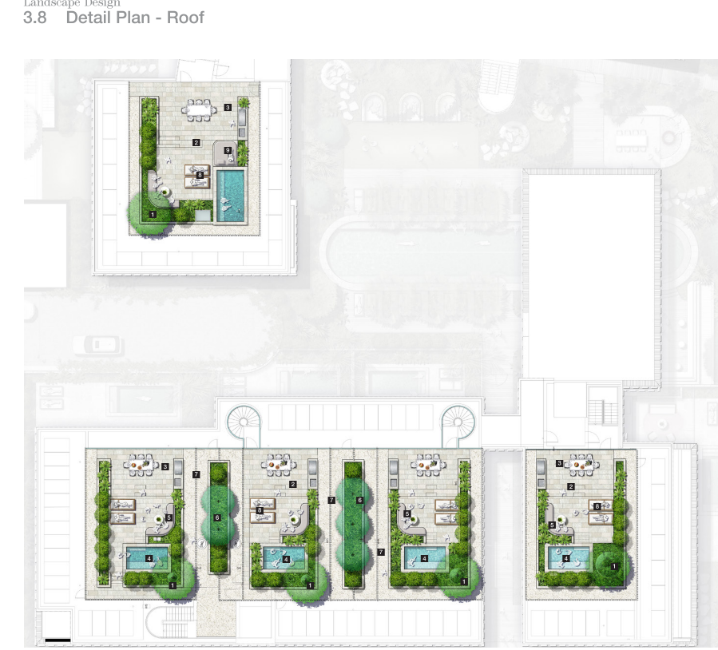

Figure 15: Rooftop landscaping proposed in R3 zone

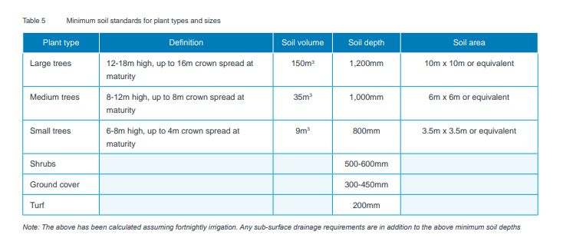
Figure 16: Apartment Design Guide extract 4P Planting on structures

The proposed rooftop landscaping is significant with planter boxes up to 1.2m deep proposed, capable of holding large trees up to 12-18m high ( refer to Figure 16 above). The scale of the landscaping is likely to result in visual impacts from the streetscape, result in increased perceived bulk and scale and negative impacts to the amenity of the locality and neighbours.

The cumulative noise impact from the use of all the rooftop terraces may result in negative impacts on adjoining properties and is an important consideration given the extent of rooftop activation proposed and the communal outdoor areas.

The application was accompanied by a Noise Impact Assessment by ATP Consulting Engineers, dated September 2024 which considered this issue. The report was reviewed by Council’s Environmental Health Officer who raised no concerns, subject to conditions of consent.

However, the cumulative impacts from 10 rooftop pool and entertaining areas, in addition to the communal pool area and other 9 ground floor pools are likely to have significant impacts on adjoining neighbours privacy, amenity and the locality.

Recommended Resolution:

A rooftop design and landscaping which is more compatible with the low and medium -density residential environment is recommended by conditioning:

            - Building heights are not further increased and limited to that currently approved
            - The size of the rooftop entertaining areas within the R3 zoning be restricted to 40m2 trafficable areas including rooftop pools, entertaining areas, seating and BBQ areas
            - Condition of consent 9(b) be amended to restrict the size of the rooftop entertaining areas within the 7F2 zoning to 40m2 trafficable areas including rooftop pools, entertaining areas, seating and BBQ areas
            - The plantings within all rooftop landscaping be restricted to 600mm deep planter boxes to support groundcovers and shrubs only
            - Hours of access to all rooftop areas be limited to 7am to 9pm daily and be used by residents only.
Refer to recommended condition of consent 9. and 103.

  - Changes to basement and inclusion of wellness centre
Changes to the basement level including the proposed wellness centre raise no concerns and are supported, subject to conditions of consent recommending the wellness centre to be used only by residents and not for commercial purposes.

Recommended Resolution:
Supported subject to conditions of consent restricting use for residents only. Refer to recommended condition of consent 102.

  - Internal Floor Plan Layout modifications, Design Verification and Quality

The proposed internal floor plan modifications include changes to unit floor plans, including some modifications to removing ensuites and robes and replace with studies and other habitable rooms capable of being used a bedrooms.

The proposed modification to the majority of the internal floor plan layouts is generally supported. The proposed modifications to Units 005 to 009 and 105 to 109 result in ensuites and robes being replaced with study rooms and other habitable rooms with no external windows or direct access to sunlight are not supported.

The lack of external windows to these habitable rooms is considered a poor design outcome and does not contribute to the well being or amenity of residents. The layout modifications to these units do not demonstrate compliance with the Apartment Design Guidelines Apartment Layout and Design Quality principles of Built form and scale, and Amenity.

As required under Cl 102 of EP&A Regulation 2021, an updated qualified Designer Statement was requested from the applicant. An updated statement was provided by DAH Architecture dated 14/11/2024, however it is considered unsatisfactory.

The statement did not :
a) verify that the qualified designer designed, or directed the design of, the modification of the development, and

(b) verify if the qualified designer designed, or directed the design of, the development for which the original development consent was granted (the original development), and

(c) explain how the development addresses—
(i) the design principles for residential apartment development, and
(ii) the objectives in the Apartment Design Guide, and

(d) verify that the modification does not—
(i) diminish or detract from the design quality of the original development, or
(ii) compromise the design intent of the original development.

Council’s Building Surveyor noted the rooms identified must comply with Building Code of Australia which requires natural light to these habitable rooms and natural ventilation or mechanical ventilation meeting AS1668.2. The door opening is considered sufficiently large enough to achieve minimum natural light (≥10%) and natural ventilation(≥5%) so long as the openings in the room off the room can achieve minimum natural light and ventilation requirements.

Recommended Resolution: The proposed internal floor plan modifications are generally supported. The study rooms and other habitable rooms with no external windows or direct access to sunlight in Units 005 to 009 and 105 to 109 result in diminished design quality and poor residential amenity. Recommended conditions of consent applied and architectural plans marked up for walls in these rooms to be removed to enable access to light and ventilation. Refer to recommended condition of consent 9(d).

5.4 BASIX Certificate
An updated BASIX Certificate was provided by the applicant BASIX Certificate number 1288442M_03, prepared by ADP Consulting, dated 07 June 2024. The amended NatHERS certificate number provided did not match within the BASIX certificate and is invalid.

Recommended Resolution: The development previously demonstrated it is capable of meeting the requirements of the BASIX SEPP. Recommended conditions of consent prior to construction certificate be included for an amended BASIX Certificate, NatHERS certificate and NatHERS stamped plans set be provided. Refer to recommended condition of consent. Refer to recommended condition of consent 9A.

5.5 Gate into the rail corridor
The initial modified plans submitted by the applicant included a gate located on the northern boundary opening directly onto the railway corridor. No consent from TfNSW was included.

Resolution: Applicant submitted amended plans removing the gate and access onto the railway corridor. No further consideration required.

- CONCLUSION

This modification application has been considered in accordance with the requirements of the EP&A Act and the 2021 EP&A Regulation as outlined in this report. Following a thorough assessment of the relevant planning controls, issues raised in submissions and the key issues identified in this report, it is considered that the modification application can be supported via a two part recommendation.

The proposal seeks consent for the modification to residential flat building including in relation to basement layout, addition of wellness centre, internal floor plan layout changes, addition of rooftop pools and changed rooftop terraces and landscaping.
The application includes requests to vary the height of buildings development standards under BLEP 2014 and BLEP 1988.

The requests to vary the height of buildings development standard are not supported in this instance given the concerns over height were raised prior to the original development consent, during the original development assessment and conditions of consent were provided accordingly. There are no environmental reasons to further vary the height development standards from the approved consent in this instance as discussed in the report above.

The proposed modification to the floor plan layouts resulting in habitable rooms within units 005 to 009 and 105 to 109 without external windows are not supported and recommended plans be modified and conditions of consent imposed to improve design and amenity.

The rooftop activation and intensive rooftop landscaping results in excessive height bulk and scale with likely noise and visual impacts on the locality and neighbours. Conditions of consent are recommended to reduce impacts.

It is considered that the key issues as outlined in Section 5 have been resolved, subject to conditions of consent and approval of the modification application, subject to the below 2 part recommendation is warranted.

- RECOMMENDATION

It is recommended:

That the Modification Application DA No 10.2022.371.2 for Modification to residential flat building including in relation to basement layout, addition of wellness centre, internal floor plan layout changes, addition of rooftop pools and changed rooftop terraces and landscaping at 29 Shirley St Byron Bay be supported via a two part recommendation and corresponding conditions of consent, pursuant to Section 4.55(2) of the Environmental Planning and Assessment Act 1979 as follows:

Part 1: Unsupported:

- The lift overrun and canopy on the rooftop for Unit 201 is not supported and must be removed from plans.
- The BLEP2014 request to further vary s4.3 Height of buildings in R3 zone is not justified. Maximum height to remain as currently approved.
- The BLEP 1998 request to further vary the maximum height (cl 40 Height) in 7(F2) zone is not justified. Maximum height to remain restricted to 9m.
- Modification to condition 54 Toilet Facilities is not supported. Condition to remain as is.

Reason:
- The lift over run is not satisfactory having regard to subsection 4.15(1)(a)(i) of the Environmental Planning and Assessment Act 1979, because it does not comply with BLEP 2014 s4.3 Building Height.
- The building height is not satisfactory having regard to subsection 4.15(1)(a)(i) of the Environmental Planning and Assessment Act 1979, because it does not comply with BLEP 1988 cl 40 Height.
- The modification to condition 54 is not satisfactory having regard to subsection 4.15(1)(a)(i) of the Environmental Planning and Assessment Act 1979, because the approval from the Council under s68 of the Local Government Act 1993 is required for the additional toilets.

Part 2 Supported, subject to conditions of consent

- Modification to basement and wellness centre, subject to conditions of consent not to be used for commercial purposes and restricting use to residents only.
- Modification to internal unit floor plan layouts, subject to conditions of consent for unit 005, 006, 007, 008, 009, 105, 106, 107, 108, 109 to remove walls for proposed additional habitable rooms because they have no access to external windows
- Staging of construction works
- Acoustic wall
- Privacy screening
- External facade changes
- Modifications to conditions of consent, subject to amendments.
- Rooftop landscaping, swimming pools and terraces approved, subject to amended plans and conditions of consent limiting the size, landscaping, and terrace hours of use, restricted to residents only.

- Pursuant to Clause 118 of the Environmental Planning and Assessment Regulation 2021, a notice of determination is to be prepared by Council following the Panel’s determination of this modification application.

- That submitters be notified of the decision.

The following attachments are provided:

- Attachment A: DA10.2022.371.2 Architectural Plans
- Attachment B: DA10.2022.371.2 Statement of Landscape Intent
- Attachment C: DA10.2022.371.2 Conditions Recommended for Modification
- Attachment D: DA10.2022.371.2 Full set of Recommended Modified Conditions

